Utilizing Isolation Forest and XGBoost Algorithms in Forecasting Unusual Trip Behavior as a Commuter Safety Indicator
CHAPTER 1

Background of the Study
Public transportation connects people to schools, workplaces, and other daily needs. Personal safety remains a concern, especially for commuters who travel alone or cannot easily call for help. These concerns can vary by time of day. A survey by UN Women (2021) in Kampala, Uganda, found that more than 80% of women felt unsafe on public transport late at night, compared with less than 8% during the daytime. The findings illustrate how perceptions of safety can change throughout the day.
In the Philippines, Corpuz et al. (2023) studied harassment on public transportation in Pampanga and found that young adults, particularly women aged 18 to 25, were most vulnerable and that reporting rates were low. When incidents go unreported, official records capture only part of what commuters experience. This motivates the development of tools that can flag trips that may need attention while they are underway, including in provincial areas such as Ilocos Norte.
Scarce incident records also make it difficult to train a system on examples of dangerous trips. Vehicle movement offers another source of information. A vehicle may stop for an unusually long time, move unusually slowly, or travel farther from its usual route. These patterns give a system a way to flag a trip for attention based on movement. Some safety concerns, including harassment inside a vehicle, may leave no observable trace in GPS data.
Current safety tools often depend on someone taking action. Agapito et al. (2025) described Pathfinders, a Philippine commuter safety application with GPS tracking and an emergency button. Its use depends on a commuter pressing the button or someone monitoring the trip on a live map. Some commercial ride-hailing services already check trips automatically. Uber’s RideCheck (Kansal, 2020), Lyft’s Smart Trip Check-In (Lyft, n.d.), and Grab’s Safety Call (Sasikumar, 2026) monitor for unusual activity such as long stops or route changes. These services illustrate how trip movement data can be used to flag potential safety concerns.
Smartphone GPS can show where a vehicle is, how far it travels from a familiar route, and how long it stays in one place. The same movement may have different meanings along the route. A long stop at a terminal may be routine, while a similar stop on a stretch where vehicles usually keep moving may warrant a check. Chapter 2 reviews how earlier studies use these signals.
This study develops and evaluates a machine learning pipeline that uses timestamps, latitude, and longitude from a smartphone’s GPS. The model is trained separately for each commuter using only that person’s own trip history. Each commuter’s usual travel patterns therefore serve as the reference for assessing their trips. The pipeline uses Isolation Forest (Liu et al., 2008) to score how unusual a trip’s movement is. It combines that score with GPS-derived movement features, including distance from the usual route and stop duration, to assign a current concern level. XGBoost (Chen & Guestrin, 2016) forecasts that level a short time ahead. A mobile data collection app records GPS data during trips and allows participants to enter trip notes. The evaluation focuses on the machine learning pipeline and excludes app usability, battery use, and alert delivery.
The model is first evaluated in a chronological replay of synthetic trips for one commuter profile. The evaluation compares forecasts with a simple baseline and measures how performance changes as the trip history grows. Planned field collection on selected routes in Ilocos Norte will allow comparison with independently documented movement events. The concern level indicates whether a trip’s movement may warrant attention.

Statement of the Problem
Safety concerns on public transport often go unreported, so commuters who travel alone or cannot call for help have few tools that notice, while a trip is under way, that it may need attention. This study therefore asks three questions.
- How can GPS data from trips along local transit routes in Ilocos Norte be used to measure speed, stops, and distance from the route?
- How can Isolation Forest and XGBoost be combined to score unusual trip movement, assign a concern level from normal to critical, and forecast that level over a short time window?
- How well does the model perform as more trips are added to the training data?

Objectives of the Study
The general objective of this study is to develop and evaluate a machine learning model that uses Isolation Forest and XGBoost to identify unusual trip movement and forecast a commuter’s trip concern level from GPS data, as an indicator that a commuter’s trip may need attention.
Specifically, this study seeks to:
- collect and clean GPS data from trips along local transit routes in Ilocos Norte and derive measures of speed, stops, and distance from the route;
- develop a model that uses Isolation Forest to score how unusual a trip’s movement is, combines that score with the vehicle’s distance from its usual route and the duration of its stops to assign a current concern level from normal to critical, and uses XGBoost to forecast that level a short time ahead; and
- evaluate model performance as each commuter’s travel history grows by training only on their earlier trips and testing on later ones, assessing forecast accuracy against a simple baseline, probability calibration, detection of documented unusual movement, and the false alarm rate on confirmed ordinary trips.

Significance of the Study
This study examines whether basic smartphone GPS data and machine learning can detect and forecast unusual trip movement without relying on incident reports or manual calls for help. By evaluating the model on recorded public transit trips, the study provides evidence on forecast accuracy and how often routine travel patterns trigger false alarms. The findings may benefit the following groups.
Researchers and the academic community. The study provides a method and baseline results for detecting and forecasting unusual movement on everyday public transit routes. Researchers and students can build on its GPS-derived movement features and evaluation approach, including the use of each commuter’s own trip history to establish their usual travel patterns.
Software developers and engineers. The study provides a technical starting point for future commuter safety applications. It describes how to clean smartphone GPS records, derive movement features such as speed, stop duration, and distance from the usual route, and use Isolation Forest and XGBoost to assess current trip movement and forecast a concern level. The evaluation results can help developers judge whether the approach is suitable for automated check-in features.
Future commuters. Future safety tools could use this approach to flag unusual movement while a trip is underway, including when a commuter cannot easily call for help. By measuring how often the model raises false alarms on ordinary trips, the study helps establish whether the approach is dependable enough for future tools.
Families and guardians. Future tools could use the model’s output to prompt a check-in when a trip’s movement differs from the commuter’s usual patterns. This could give families and trusted contacts a reason to check on someone without having to monitor a live map throughout the trip.

Scope and Delimitations of the Study
This study develops and evaluates a machine learning model that detects unusual trip movement and forecasts the highest concern level within a short time window. The study population consists of adults who regularly commute on selected public transit routes in Ilocos Norte. Volunteers who meet these criteria are recruited through criterion sampling, a form of purposive sampling.
Participants use a mobile data collection app to record GPS data during trips and enter trip notes. The model uses smartphone GPS timestamps, latitude, and longitude to derive movement features such as speed, stop duration, and distance from the usual route. Isolation Forest scores how unusual a trip’s movement is. The model combines that score with GPS-derived movement features to assign a current concern level from Normal to Critical, and XGBoost forecasts the highest concern level within the forecast window.
Recorded trips are evaluated in chronological order. Each commuter’s trip history is kept separate, and the model uses only that commuter’s earlier trips to train for each test trip. The study compares forecast accuracy with a simple baseline, checks how closely predicted probabilities match observed concern levels, and measures how often the model flags documented unusual events and raises false alarms. It also examines how performance changes as more trips become available for training.
The study is limited to movement patterns observable through GPS. Incidents that leave no observable change in vehicle movement, including some forms of harassment, fall outside the model’s scope. Incident reports are excluded from training, while trip notes, when available, are used during evaluation to check whether the model flagged documented unusual events. The app’s role is limited to data collection. App usability, battery consumption, alert delivery, and emergency response are outside the evaluation. The findings apply to the participants, routes, and travel conditions covered by the study.

Definition of Terms

CHAPTER 2
REVIEW OF RELATED LITERATURE
This chapter reviews studies on commuter safety and the use of GPS data to detect unusual trip movement. It explains the research gap that motivates the study and reviews how earlier studies collected and cleaned GPS data, measured stops and route deviations, and used those measures to build and evaluate models. It also explains why a reading can be unusual for a trip without showing that a commuter is in danger.
2.1 Study Context and Research Gap
2.1.1 Commuter Safety in the Philippine Context
UN Women (2021) surveyed 2,548 women in Kampala, Uganda. More than 80% felt unsafe on public transport late at night, compared with less than 8% during the day. The survey shows how perceptions of safety can vary by time of travel.
Corpuz et al. (2023) found low reporting of harassment on public transport in Pampanga. Young adults, especially women aged 18 to 25, were among those most affected. Harassment can occur without a change in vehicle movement, so GPS captures only some events relevant to commuter safety.
Okamura et al. (2013) included security in their study of what jeepney passengers value in Metro Manila. In Sarrat, Ilocos Norte, Baluan et al. (2026) studied jeepney and tricycle drivers. These studies provide context for the types of trips and safety concerns relevant to this study.
Pathfinders lets users follow a trip on a map or press an emergency button (Agapito et al., 2025). Ride-hailing services also check trips automatically. Uber and Lyft can check in after unexpected stops (Kansal, 2020; Lyft, n.d.). Grab can call a passenger after a long stop, a sudden route change, or a trip that stops progressing (Sasikumar, 2026). These are examples of how unusual movement can prompt a check-in.
2.1.2 Related Studies and Research Gap
Earlier studies show that smartphone GPS can support trip monitoring. SayfTrip compares a user’s current location with earlier runs of the same route and issues alerts at preset distance bands (Edwards & Hosein, 2025). Studies of intercity coaches identify unusual stops from GPS, including pauses that are long for their location (Deng et al., 2024; Sabir et al., 2025). Research on bus driving events links movement patterns to pedestrian and cyclist crashes near stops (Li et al., 2021). These studies address route deviation, stop detection, and a specific road safety outcome.
The studies reviewed here leave one question open. Can a model learn from a commuter’s earlier trips, detect unusual stops and detours during a trip, and forecast the highest concern level in the next minute using GPS data alone? This study examines that question for local public transport in Ilocos Norte. The concern level indicates when unusual movement may warrant a check-in.
2.2 Data Gathering
2.2.1 Recording Trips
The phone saves the time, latitude, and longitude of each GPS reading. Edwards and Hosein (2025) stored these readings by route and trip. Bagheri et al. (2020) used smartphone GPS to record volunteers’ daily travel.
The sampling interval affects what the trace can show. Newson and Krumm (2009) found that sparse fixes made map matching less accurate. Deng et al. (2024) and Sabir et al. (2025) describe how sparse coach GPS can obscure short stops. A shorter interval provides more opportunities to observe low movement during a pause and reduces the time between successive observations of a possible detour.
Bagheri et al. (2020) recorded a location every 10 seconds while a person was moving. Mears et al. (2021) requested locations at the same interval. These studies support the planned 10-second interval. A stop of about 40 seconds can span several readings, depending on when it starts and whether the phone misses any readings.
2.2.2 Organizing Trip Records
A trip starts at boarding and ends at arrival. The study records the expected route and direction and keeps each commuter’s trips separate. This lets the model compare a new trip with earlier trips by the same commuter, following the use of saved route histories by Edwards and Hosein (2025).
2.2.3 Collecting Optional Trip Notes
If trip notes are collected, commuters say whether anything unusual happened, what happened, and roughly when it began. How events are counted and timed affects the evaluation (Sørbø & Ruocco, 2024). The study uses the notes to check alerts during field evaluation.
2.2.4 Sampling Method
The study uses criterion sampling, a form of purposive sampling in which participants must meet predefined conditions (Etikan et al., 2016; Palinkas et al., 2015). Ankunda and Venter (2025) applied eligibility criteria, including smartphone ownership and informed consent, in a GPS study of informal public transport. This study recruits adults who regularly ride a selected route, have a compatible smartphone, and give informed consent. Regular riders can record enough trips in both directions to build a personal travel history.
2.2.5 Participant Count
Liu et al. (2013) recruited five volunteers with GPS-equipped cars for a nine-week travel survey. They used the trip records to evaluate a model of individual travel patterns. In public transport, Ankunda and Venter (2025) used a one-day pilot with 12 people to test GPS data collection. Together, these studies provide examples of using small groups to test GPS recording and trip-history methods.
This study proposes five commuters for its initial field evaluation. Five separate histories allow the study to compare results across riders while keeping recruitment and follow-up manageable during the month-long study. At 60 trips per commuter, the target is 300 trips across five histories. Five is a feasibility target for the selected commuters and routes. The findings will describe those histories and will not estimate safety performance for the wider commuter population.
2.2.6 Trip Sample Size
Viechtbauer et al. (2015) give a formula for the number of independent observations needed to see an event at least once. Here, p is the assumed probability of the event on one trip, and n is the number of trips. If the trips are independent and share the same event probability, the chance of seeing no event is (1 − p) raised to the power n. For a 95% chance of seeing at least one event, the chance of seeing none must be at most 5%.
1 − (1 − p)ⁿ ≥ 0.95
n ≥ ln(0.05) ÷ ln(1 − p)
For p = 0.05, n ≥ ln(0.05) ÷ ln(0.95) ≈ 58.40
Rounding up gives 59 trips. The study sets a target of 60 trips per commuter so that 30 can be recorded in each direction. The 5% event probability is a planning assumption, and repeated trips by the same commuter may be related. This calculation addresses the chance of observing at least one event. Estimating detection accuracy would require enough independently documented events and ordinary trips.
Silvey and Liu (2024) used learning curves to show how classification performance changes as more training data become available. This study compares forecasts at different amounts of trip history to see whether additional trips improve performance.
2.2.7 Recording Period
Winkler et al. (2026) collected four weeks of smartphone GPS and travel diary data, showing that recording can extend over several weeks. This study plans for about 30 recording days. One trip in each direction per recording day gives 60 trips in 30 days. The schedule also allows later forecasts to be compared using the previous 7 days, the previous 14 days, and the full available history.
2.3 Data Preprocessing
2.3.1 Cleaning GPS Records
Zheng (2015) identifies cleaning, finding stops, and matching GPS readings to roads as common steps in preparing trip data. Cleaning reduces the effect of noisy readings before the study measures movement.
Chen et al. (2016) discuss using implausible segment speed to screen for GPS errors and note that the method can miss smaller position errors. In smartphone trajectory preprocessing, Verma et al. (2024) screened for segment speeds above 50 m/s, acceleration outside −10 to 10 m/s², and large reported accuracy radii. These are examples of data-quality checks. A reading that passes them can still reflect GPS drift, so apparent route deviations must be interpreted in context.
The study removes invalid and duplicate readings and flags gaps. Missing readings can hide short stops (Deng et al., 2024; Sabir et al., 2025). A gap breaks the stop record because the vehicle’s movement during that time is unknown.
2.3.2 Measuring Trip Movement
Deng et al. (2024) estimated stop durations from sparse coach GPS. Sabir et al. (2025) compared stop duration with historical expectations for a route and used 5 km/h as an example of a low-speed cutoff for identifying brief pauses. This supports deriving stop duration from consecutive low-motion observations and interpreting it relative to where the vehicle stops.
Distance from the usual route is also measured. Edwards and Hosein (2025) used the shortest distance between the current position and the positions of earlier trips on the same route. Newson and Krumm (2009) used map matching to find the most likely road behind noisy positions.
Li et al. (2021) derived acceleration, deceleration, and stop duration from bus trajectories and used them to identify critical driving events. These measures provide different views of a trip. Speed describes movement between fixes, elapsed stop time describes how long low movement continues, and route distance captures spatial deviation. A prolonged stop can occur without a route deviation.
2.4 Model Development
2.4.1 Signals of Unusual Movement
Edwards and Hosein (2025) showed that a trip can be monitored by comparing incoming fixes with earlier runs. Their prototype assigns four levels using fixed route distances. Deng et al. (2024) and Sabir et al. (2025) show how stop behavior can provide a complementary signal. Combining the two measures allows the study to examine unusual stops on the familiar route as well as detours during continuous movement.
The place and time of a reading affect how it should be interpreted. Chen et al. (2013) grouped taxi trajectories by time in iBOAT, while Sabir et al. (2025) used historical stop behavior to assess coach stops. These studies support using relevant earlier trips and route context when judging a new GPS reading. Traffic, scheduled stops, and familiar detours can explain readings that look unusual against a broader reference.
2.4.2 Scoring Unusual Movement with Isolation Forest
Isolation Forest uses trees to separate observations. Readings that take fewer splits to separate receive higher anomaly scores (Liu et al., 2008). Hofmockel and Sax (2018) trained Isolation Forest on vehicle data assumed to be mostly ordinary, then tested it on rides with known unusual events. This supports using the method to score movement when training labels are scarce.
In trajectory research, iBAT uses the principle of isolation to detect unusual taxi paths, and iBOAT extends this line of work to identify anomalous portions of a trip online (Zhang et al., 2011; Chen et al., 2013). These trajectory methods use their own spatial representations. In the present study, Isolation Forest scores combinations of GPS-derived movement features against each commuter’s earlier trips. The score ranks how unusual the current movement is within that history.
2.4.3 Assigning Concern Levels and Interpreting Thresholds
The study compares stop duration and Isolation Forest scores with earlier trips. Leys et al. (2013) recommend the median and median absolute deviation to identify readings far from the usual range. NIST/SEMATECH (n.d.) reports a modified z-score rule that flags absolute values above 3.5 as potential outliers. The study combines its score cutoffs with route-distance bands to assign levels from Normal to Critical.
A safety threshold needs evidence linking a cutoff to a specific harmful outcome. Section 35 of the Philippine Land Transportation and Traffic Code sets legal speed limits by vehicle and road conditions. GPS cleaning uses a separate speed cutoff to screen for errors. SayfTrip uses distance cutoffs to trigger alerts (Edwards & Hosein, 2025). Li et al. (2021) studied crashes involving pedestrians and cyclists near bus stops.
The reviewed studies provide no validated cutoff for personal danger based on route distance, stop duration, or an anomaly score. Critical means the movement crossed the model’s highest concern cutoff. Normal means the measured movement stayed within its ordinary range. Field observations are needed to determine how these levels relate to commuter safety.
2.4.4 Creating Forecast Labels
XGBoost needs a label for each training example. Sabir et al. (2025) used model-generated labels to supplement a small set of labelled coach stops. This study also derives labels from the available data.
For each point in a training trip, the label is the highest concern level reached in the next minute. The model learns to predict that label using only information available at the time of the forecast. The label describes movement under the study’s rules.
2.4.5 Training the Forecast Model with XGBoost
Chen and Guestrin (2016) introduced XGBoost, which builds a series of decision trees to improve predictions. Zhu et al. (2022) used it to predict travel time between bus stops. Mousa and Ishak (2018) used it to predict freeway travel times. Both studies show how XGBoost can predict a later outcome from transport data.
This study uses XGBoost to forecast the highest concern level in the next minute from speed, stop duration, route distance, and other information available at the time. Following Frank and Hall (2001), the model asks three questions: whether the level will reach at least Minor, Major, or Critical.
2.5 Model Evaluation
The evaluation tests forecasts on later trips, compares them with a persistence baseline, checks probability calibration, and compares alerts with independently reviewed trip notes when available.
2.5.1 Testing on Later Trips
Random splits can make errors look smaller when observations are related by time or group (Roberts et al., 2017). The study keeps each trip intact and tests on later trips.
Each forecast uses only the same commuter’s earlier trips. After a trip is tested, it can join the history for the next trip. Gama et al. (2013) describe this approach as testing before updating.
Early forecasts have less trip history to draw on. Reiss et al. (2024) call this a cold start. Silvey and Liu (2024) use learning curves to show how performance changes as training data grow. The study uses the same idea to compare forecasts at different amounts of trip history.
Routes and traffic can change. Keeping fewer old trips may help the model adapt, but it leaves less data for training (Gama et al., 2013, 2014). The study compares different history lengths. Any setting chosen from this comparison should be checked on new trips to avoid overstating performance (Cawley & Talbot, 2010).
2.5.2 Comparing Forecasts with a Baseline
The baseline assumes the current concern level stays the same. The study compares the forecast and baseline against the same reference labels. A confusion matrix shows how often each predicted level matches the reference level and which levels are confused. Trip-note checks are reported separately because the choice of event metric affects the results (Sørbø & Ruocco, 2024).
2.5.3 Checking Forecast Probabilities
A probability is well calibrated when it matches how often the outcome occurs. For example, windows given a 30% chance of reaching Major or higher should reach that level about 30% of the time. Boosted trees can need probability calibration (Niculescu-Mizil & Caruana, 2005), and calibration error measures the gap between predicted and observed frequencies (Guo et al., 2017). The study also checks how often its prediction sets contain the reference level, following Angelopoulos and Bates (2021).
2.5.4 Checking Alerts Against Trip Notes
Edwards and Hosein (2025) discuss the risk of frequent false alerts, and Cvach (2012) documents alarm fatigue in a clinical setting. These studies motivate reporting how often an alert occurs and how often it matches the event definition. In the prototype replay, alerts can be compared with the model-derived targets. Field false-alarm rates require trips independently reviewed for the presence or absence of the defined movement events.
If trip notes are available, the study compares the alert time with the reported start of the event. It counts early warnings, late alerts, and missed events. False alarms are counted only on reviewed trips confirmed to have no qualifying event.
2.6 Conceptual Framework
Figure 1 shows how the model learns what is usual from each commuter’s earlier GPS trips. Movement that recurs across those trips becomes part of the commuter’s usual pattern. Isolation Forest scores how unusual each new reading is based on that history. The model assigns a concern level and uses XGBoost to forecast the highest level in the next minute. Trip notes, when available, support a separate field check.
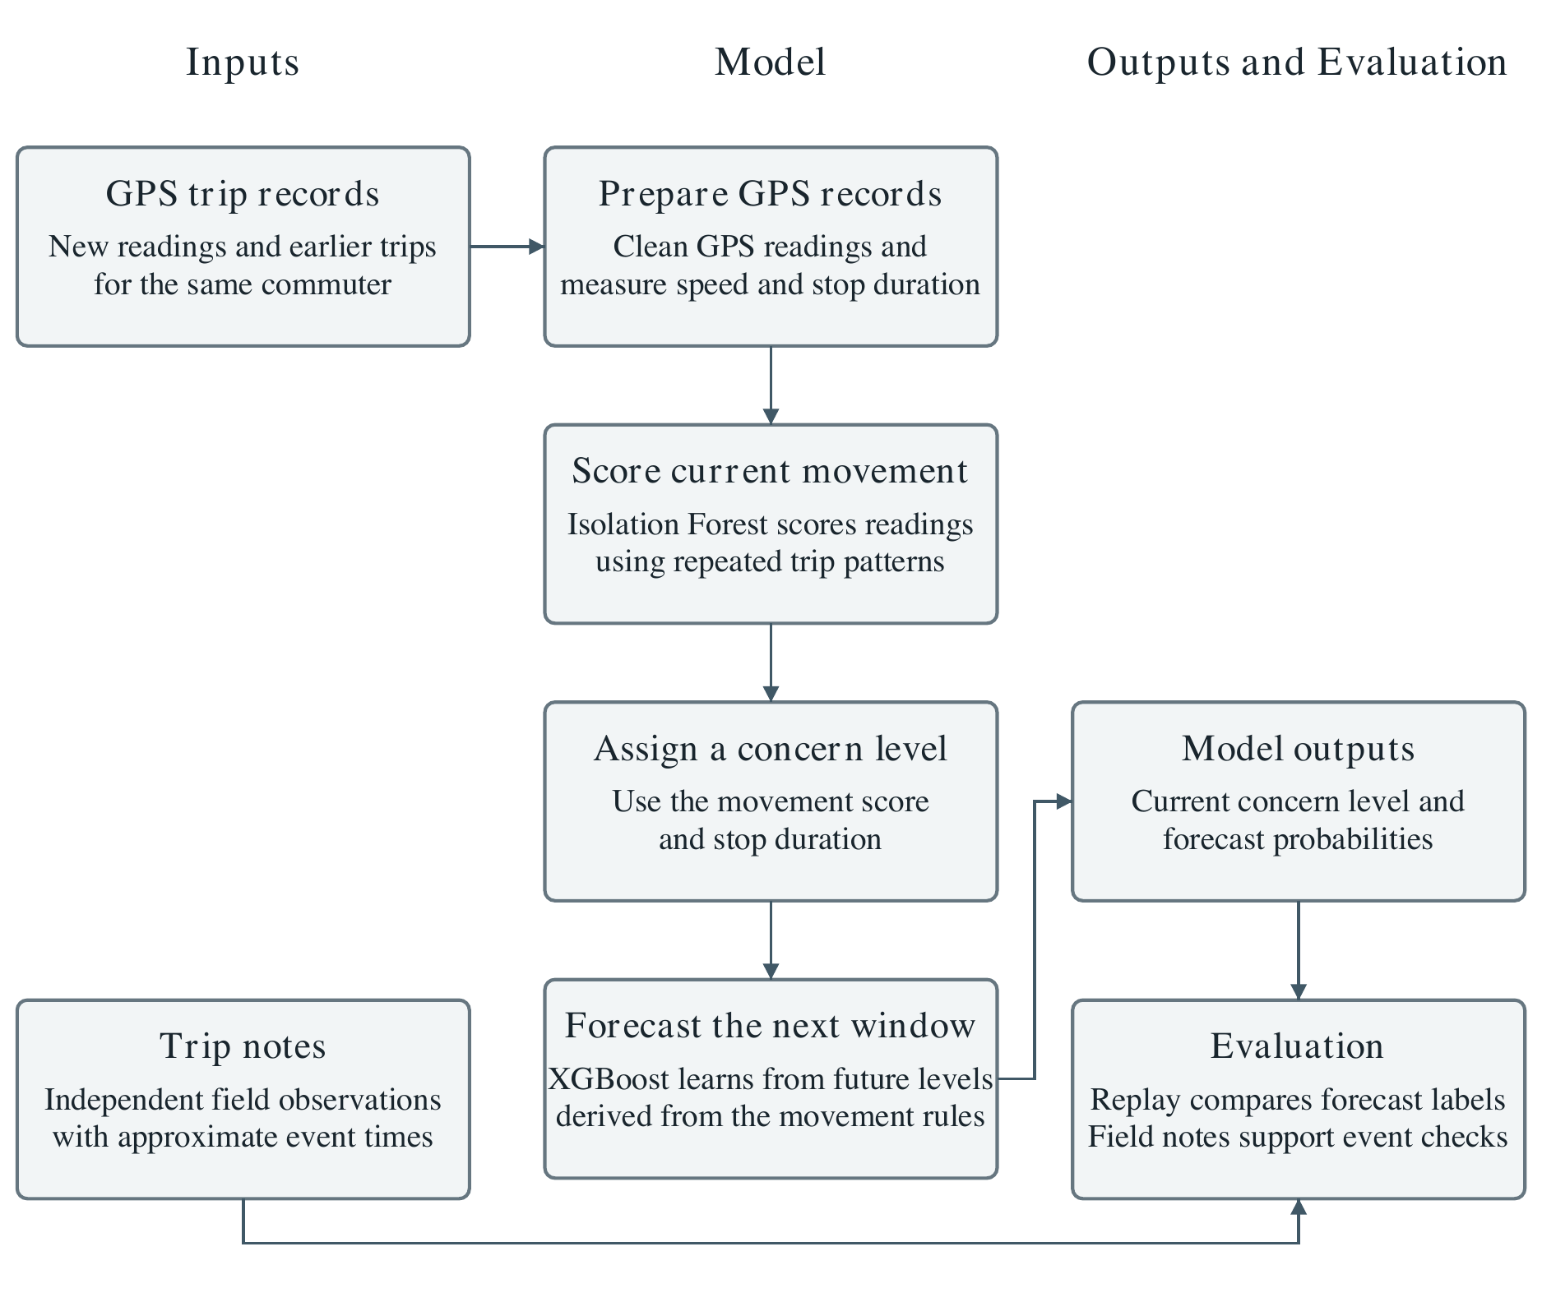
Figure 1. Conceptual framework of the study. Trip notes are used only for field evaluation.
CHAPTER 3
METHODOLOGY
3.1 Introduction
This chapter explains how the study was planned. It starts with the research design, which has three parts that match the three objectives. It then describes the study setting, the participants, and how the sample was chosen. The next three sections follow the objectives in order: data gathering and preprocessing (Objective 1), model development (Objective 2), and model evaluation (Objective 3). The chapter ends with ethical considerations and a summary of the study settings. Each setting that has a number is given with the reason for it. Table 3.1 at the end of the chapter lists them all in one place.
3.2 Research Design
The study uses a developmental and experimental design with three parts. The first part prepares GPS trip records and derives speed, stop duration, and distance from the route. The second develops a model that scores current movement and forecasts the highest concern level over a short window. The third evaluates the model in chronological order using only earlier trips for each forecast. The initial evaluation uses generated trajectories. The field protocol uses smartphone GPS records and post-trip notes from regular commuters. Figure 2 shows the three parts of the study.
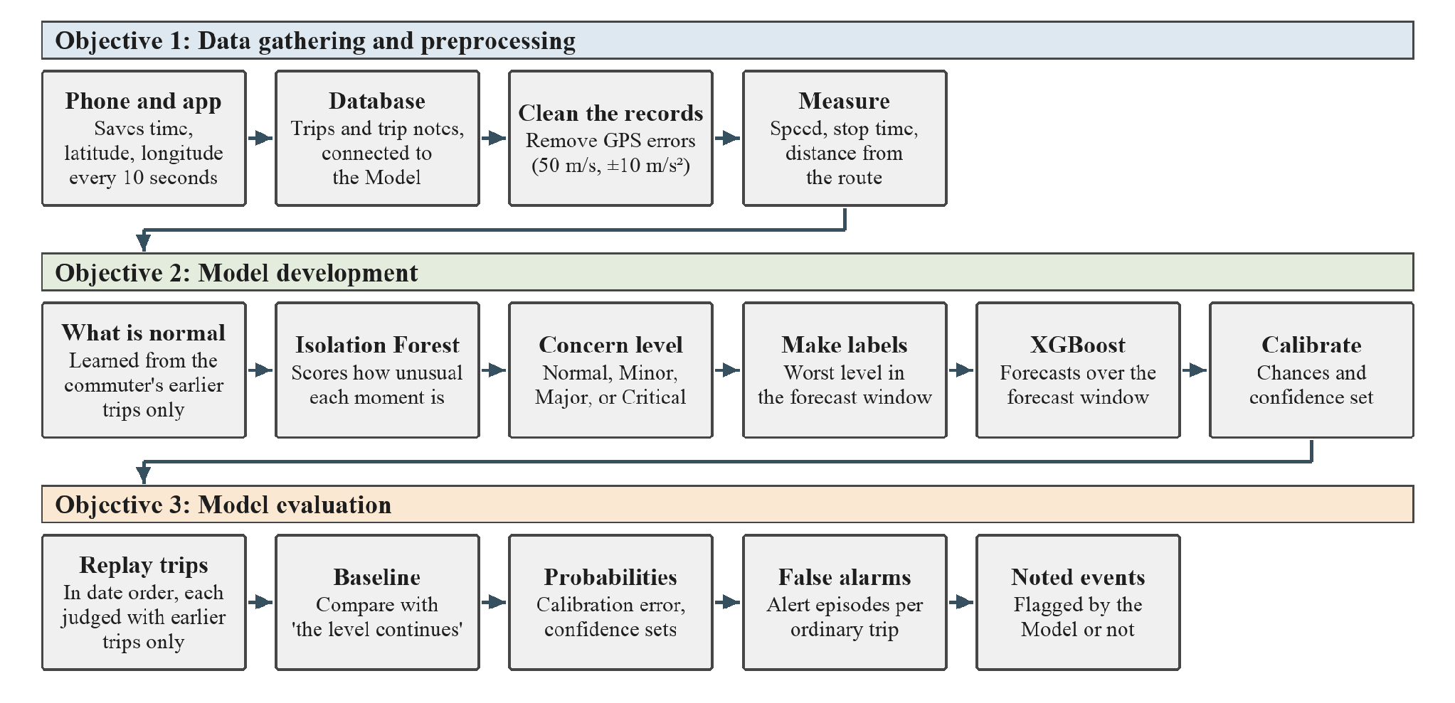
Figure 2. The three parts of the study and the steps in each.
The replay follows the advice of Roberts et al. (2017) and Hyndman and Athanasopoulos (2021), who say that data connected by time should be tested by learning from earlier records and judging on later ones. The study does not follow commuters after the trips, and it does not use incident reports. Safety incidents are scarce and many are never reported (Corpuz et al., 2023). The Model therefore learns what is normal from the trips themselves. Its output shows that a trip looks unusual. It does not show that anything harmful has happened.
3.3 Study Setting, Participants, and Sampling
3.3.1 Study Setting
The study takes place in Ilocos Norte. Trips are recorded on local transit routes in the province. The study is not limited to one kind of vehicle. Any public transport vehicle on a chosen route can be recorded, such as a jeepney, a tricycle, a bus, or a van, because the app saves only the position of the volunteer's phone and does not depend on the vehicle. Each volunteer notes the vehicle type for every trip, because vehicles can differ in how they travel. Some are faster than others, some stop more often or for longer to pick up passengers, and some may take slightly different roads on the same route. These differences change how long a trip takes and what a normal stop looks like. Noting the vehicle type lets the results be checked for each type, and it shows whether a stop or a slow stretch that looks unusual is simply normal for that kind of vehicle. If trips from different vehicle types are mixed in one history, the Model learns one idea of normal for all of them. A stop that is unusual for a bus may look normal because a tricycle often stops there, so the Model may miss it. This is a limit of the study. Each volunteer rides their own usual route. A commuter's route has its own route reference, and each commuter has an independent trip history. The trips of one commuter never enter the history of another.
3.3.2 Participants
The field protocol recruits adult volunteer commuters who regularly ride a selected route, have a smartphone capable of running the recording app, and provide informed consent. Volunteers record trips they already make. The initial replay uses a simulated commuter profile.
3.3.3 Sampling Method
The study uses criterion sampling. Eligible participants are adults who regularly ride a selected route, have a compatible smartphone, and give informed consent. Section 2.2.4 explains the basis for these criteria.
3.3.4 Sample Size and Recording Period
The proposed field evaluation targets five commuters, with 60 trips per commuter and 30 trips in each direction. At one trip per direction per day, the plan calls for about 30 recording days per commuter. Sections 2.2.5 to 2.2.7 explain the basis for these targets.
The initial evaluation used 60 synthetic trips representing one commuter profile on one route, with 30 trips in each direction and 2,936 timestamped locations at 10-second intervals. The trips cover 30 simulated travel days. The evaluation used zero field participants and zero participant-recorded trips. It used generated CSV traces and direction-specific route references as inputs to the replay.
3.4 Data Gathering and Preprocessing (Objective 1)
3.4.1 The Recording App
For field collection, the prototype smartphone logger is intended to save the timestamp, latitude, and longitude of each location fix. The app supports data collection. The evaluation covers the model and excludes app usability, battery consumption, and alert delivery.
3.4.2 Recording Interval
The planned field logger requests a location fix every 10 seconds. In the initial evaluation, the generated GPS records were spaced at 10-second intervals. Section 2.2.1 explains the literature supporting this cadence.
3.4.3 Recording Procedure
Under the field protocol, a volunteer starts recording at boarding and stops at arrival. Each trip is associated with the volunteer’s code, route, direction, vehicle type, and date. The proposed app stores trip records and post-trip notes together. The initial model replay reads trip files from separate direction folders and uses the associated route reference.
3.4.4 Trip History and Mapped Comparison
The model learns usual movement from repeated GPS trips by the same commuter. The map in Figure 3 shows the route used in the initial replay. The mapped line also provides the basis for the fixed-distance comparison described in Section 3.6.9.
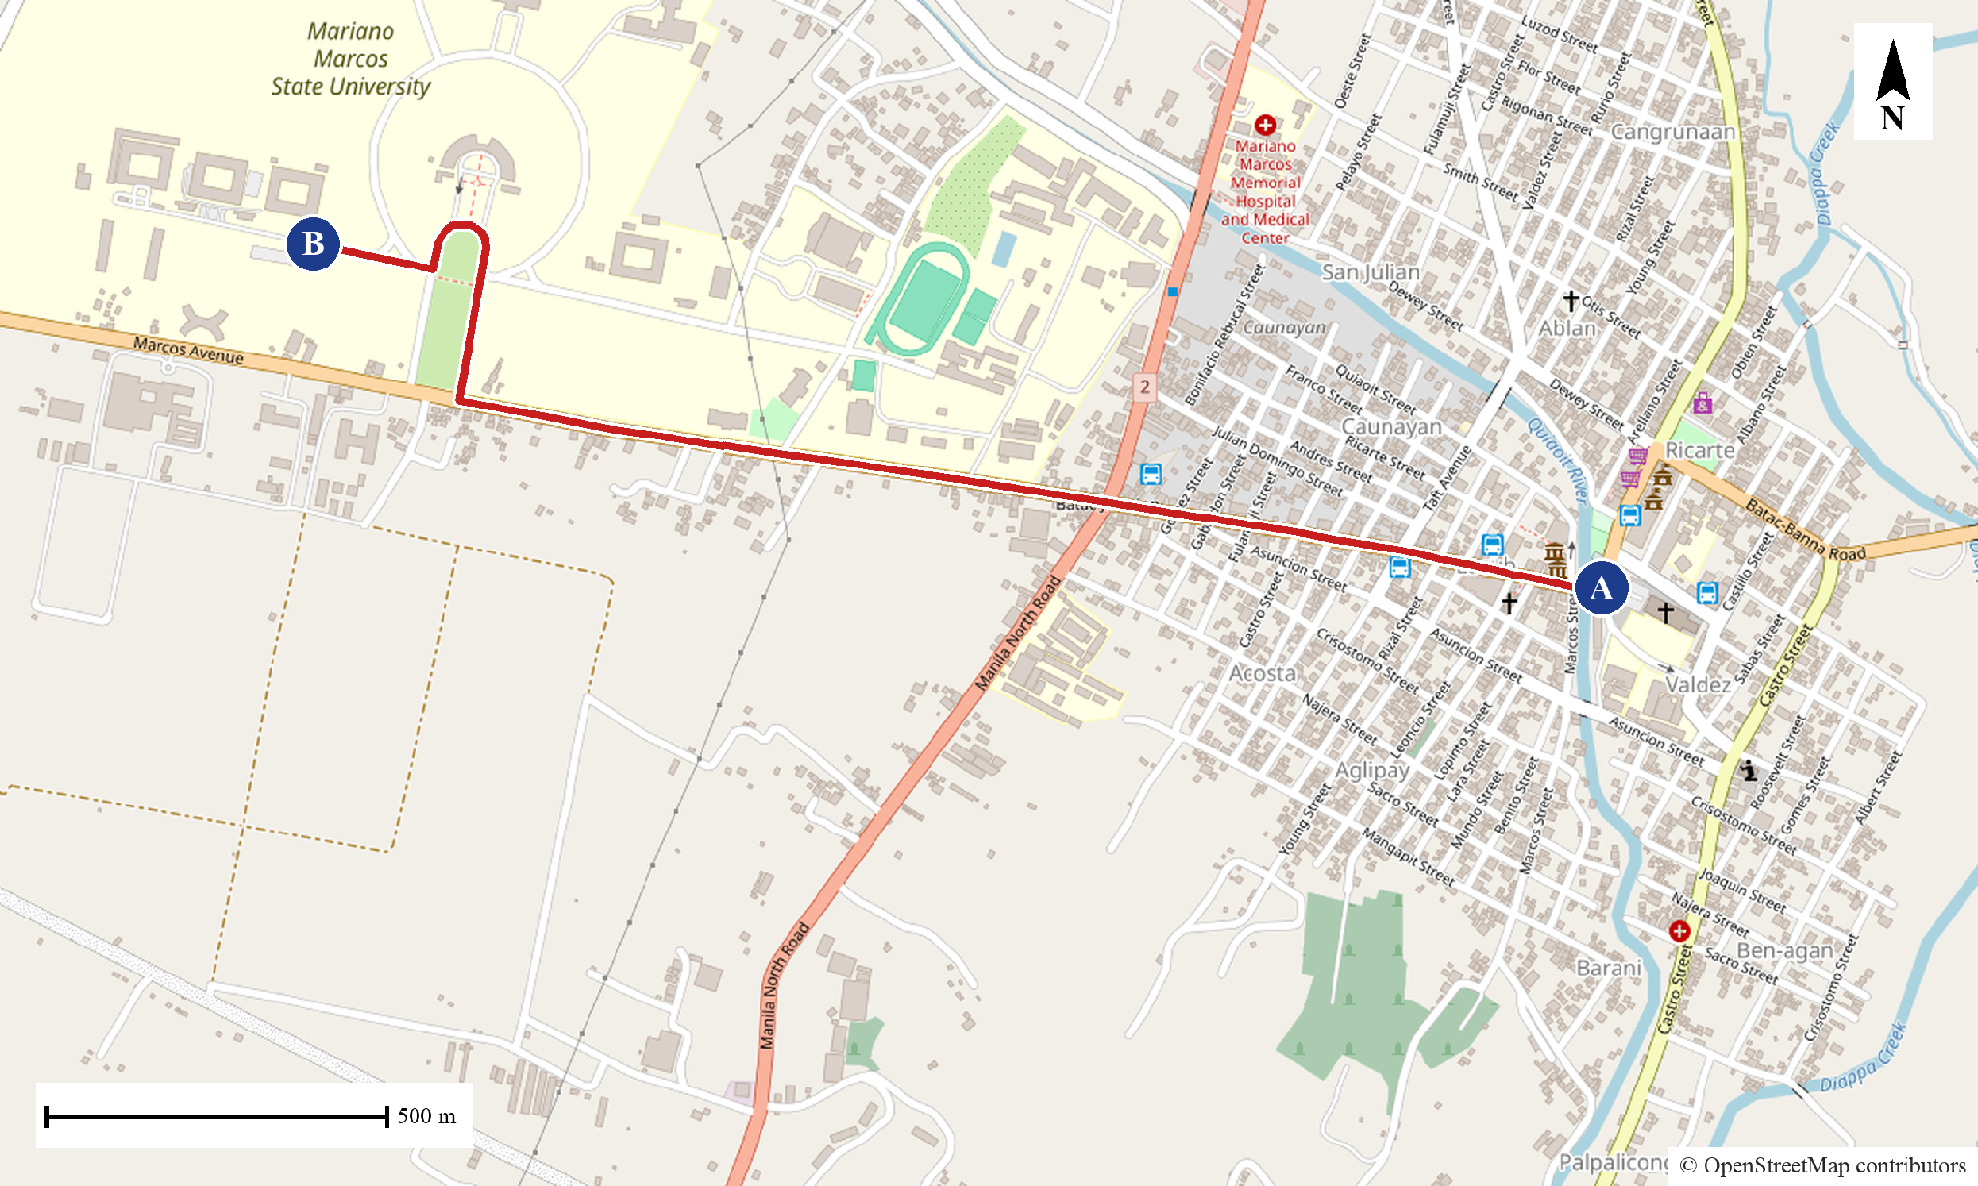
Figure 3. Route reference of the first route. Point A is the start of the recorded trips and point B is their end. Map data © OpenStreetMap contributors.
3.4.5 Trip Notes
Under the field protocol, the app asks the volunteer after each trip whether anything unusual happened. The form asks for the event type, approximate time, and a short description. It distinguishes observable movement events, such as unexpected stops and detours, from experiences such as feeling unsafe. Trip notes are kept separate from model training and provide evidence for the event evaluation in Section 3.6.2. Asking for an approximate time supports event matching within a stated window (Sørbø & Ruocco, 2024).
3.4.6 Cleaning GPS Errors
Each file is cleaned before anything else, because preprocessing comes early in the process (Zheng, 2015). First, rows with a missing or unreadable time, latitude, or longitude are removed, the rows are put in time order, and repeated times are removed. Second, if the file has an accuracy column, records with a reported error radius above 50 m are removed. Third, a record is removed if it implies a move faster than 50 m/s from the last kept record. Fourth, a record is removed if it implies an acceleration outside the range of -10 to 10 m/s². The speed, accuracy, and acceleration limits come from Verma et al. (2024). The speed and acceleration checks are repeated until no record breaks a limit. At a 10-second interval the acceleration limit is rarely reached, and the speed limit does most of the work. A speed of 50 m/s is 180 km/h, far above the highest limit of 80 km/h in the Land Transportation and Traffic Code (1964).
The study records how many records were removed by each rule for every trip. A trip is set aside if it loses more than one record in five or has fewer than 20 records left, because it can no longer be followed reliably. The list of trips set aside, and the reason for each, is reported with the results so that the rule can be reviewed.
3.4.7 Measuring Speed, Stops, and Distance from the Route
From the clean records, the following measures are worked out for every moment of a trip. Speed is the distance between two records divided by the actual time between them, which avoids errors when a record is late or missing. Acceleration and turning come from the changes in speed and direction. A vehicle counts as stopped when its speed is below 5 km/h, the low-speed limit used by Sabir et al. (2025). Stop time is how long it has stayed below this speed.
Every position is projected onto the route reference for its direction. This gives the route progress, which is how far along the route the vehicle is, and the distance from the route line. This is similar to the map matching of Newson and Krumm (2009). The study also measures the shortest distance between the position and the positions of earlier trips on the same route, as Edwards and Hosein (2025) did. Speed, stopping, and route distance are also summarised over the minute before each moment, The look-back stays at one minute, even when the forecast window is changed. Figure 4 shows route progress and the distance from the route for one position.
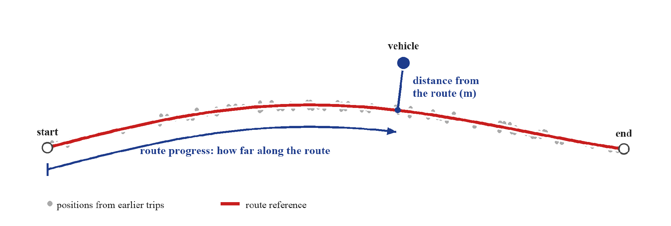
Figure 4. Route progress and distance from the route for one position of a vehicle (illustration).
3.5 Model Development (Objective 2)
3.5.1 What Is Normal for Each Place and Time
The Model first learns what is normal for a commuter from that commuter's own earlier trips. It divides each route direction into stretches of road. For each stretch, and for each part of the day, it learns the usual speed and how much speed varies. What is normal depends on the place and time, as in iBOAT (Chen et al., 2013) and in the stop comparison of Sabir et al. (2025). The day is split into four parts: night, morning, midday, and afternoon. Night is kept apart because UN Women (2021) found that safety worries are much higher at night. The split is also tested: Section 3.6.5 compares the four parts with a split into night and day only and with no split at all. Where a stretch has few trips in one part of the day, the Model leans on the all-day figure for that stretch. The first stretch length is 100 m, and the Model leans on the all-day figure with a strength of 8 trips. No source gives these values, so Section 3.6.5 tests other values around them.
3.5.2 Scoring Unusual Movement with the Isolation Forest
An Isolation Forest (Liu et al., 2008) gives each moment a score for how easy it is to separate from the rest. Liu et al. found that 100 trees built on samples of 256 points were enough, and this study uses the same settings. Two forests are built, each from half of the history trips. A history trip is scored by the forest that did not see it, and a new trip gets the average of both. This stops the Model from scoring trips it has already memorised, which would make the scores look too normal. Cawley and Talbot (2010) warn about the same problem of judging on data that was used to build the model. Scores are smoothed over 30 seconds so that a single odd record does not decide the level. Figure 5 shows how this works.
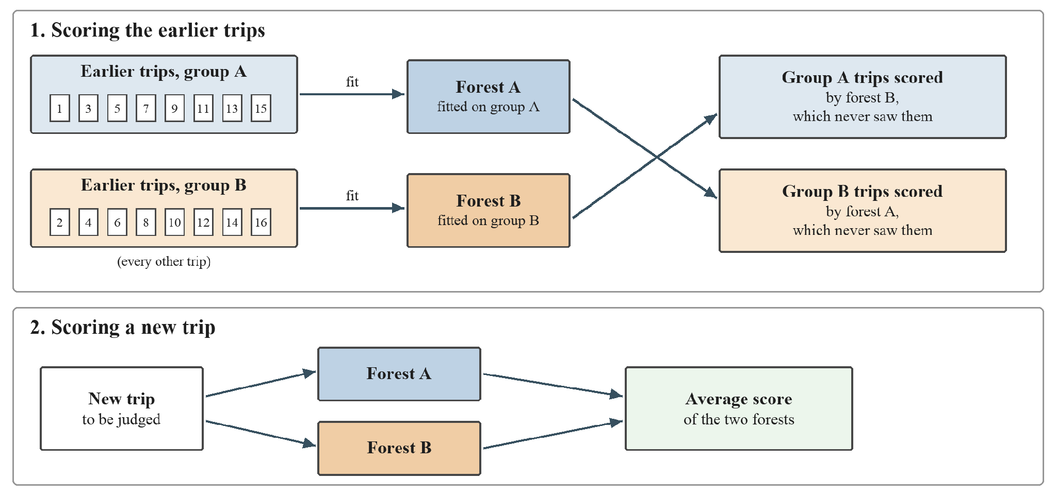
Figure 5. How the two Isolation Forests score the earlier trips and a new trip.
3.5.3 Setting the Concern Level
Each moment gets the highest of three levels. The first level comes from the forest score. The second comes from the distance from the route: up to 150 m is Normal, up to 500 m is Minor, up to 1,000 m is Major, and beyond 1,000 m is Critical (Edwards & Hosein, 2025). While the commuter has fewer than 5 earlier trips in that direction, the distance is measured from the route line. After that, it is measured from the commuter's earlier trips, so a detour that the commuter makes often becomes familiar and counts as Normal. The number 5 has no source, so it is treated as an experiment in Section 3.6.5. The third level comes from how long the vehicle has been stopped. The distance bands are alert settings adopted from SayfTrip. They classify route deviation for this study.
The forest score and the stop time are turned into levels with a robust score. This measures the distance from the median in units of the median absolute deviation, so that a few extreme trips do not distort it. The forest score is compared with the scores of the history. The stop time is compared with the lengths of stops that finished in the history, so a stop is judged against what is usual for the route and not against a fixed number of seconds, as in Sabir et al. (2025). Leys et al. (2013) recommend 2.5 as a cut-off, and Iglewicz and Hoaglin recommend labelling scores above 3.5 as potential outliers (as cited in NIST/SEMATECH, n.d.). The levels Minor, Major, and Critical start at robust scores of 2.5, 3, and 3.5, with 3 selected as the midpoint. These are thresholds for unusual movement and carry no validated interpretation as levels of personal danger. Figure 6 shows how the three levels are combined, with an example.
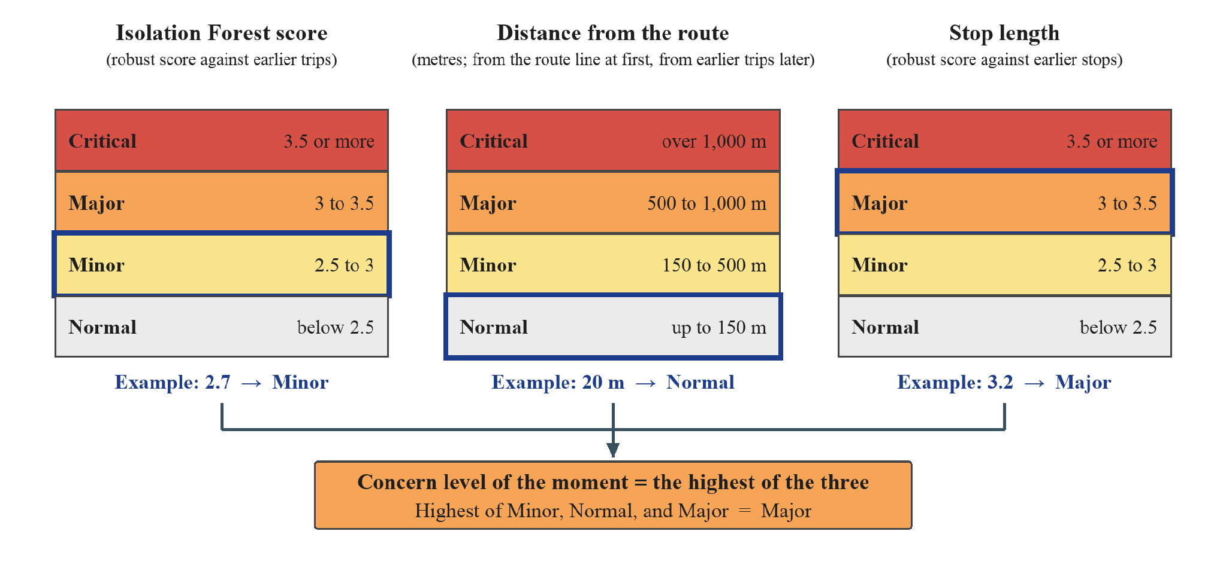
Figure 6. How the concern level is set from the forest score, the distance from the route, and the stop length (illustrative values).
3.5.4 Making Labelled Data from Unlabeled Trips
XGBoost learns from examples that come with an answer. The labels are made after the concern level is set, because they are built from it. The recorded trips have no answers, because nobody marks which moments were unusual. The study therefore makes the answers from the trips themselves, in four steps. Bakker et al. (2025) and Yuan et al. (2024) also made labels from unlabeled data to train supervised models.
First, every moment of a trip gets a concern level from Normal to Critical (Section 3.5.3). Second, for each moment, the Model looks at the forecast window, which is the short time that comes after it. Third, the label of the moment is the worst concern level found in that window. Fourth, the measures at the moment (Section 3.4.7), such as speed, stop time, and distance from the route, are the input, and the label is the answer that XGBoost learns to predict. Near the end of a trip, less than the forecast window remains, so the label uses the records that are left.
Figure 7 shows an example from one trip in the test data. The records on the left have only the time, the latitude, the longitude, and the Isolation Forest score. On the right, the speed, the stop time, and the distance from the route are added as inputs, and each moment has its label. For example, at 09:08:09 the vehicle is moving at an ordinary 28.9 km/h with no stop, but the label is Major because the vehicle stops soon after. In this way, XGBoost learns what the moments before a long stop tend to look like.
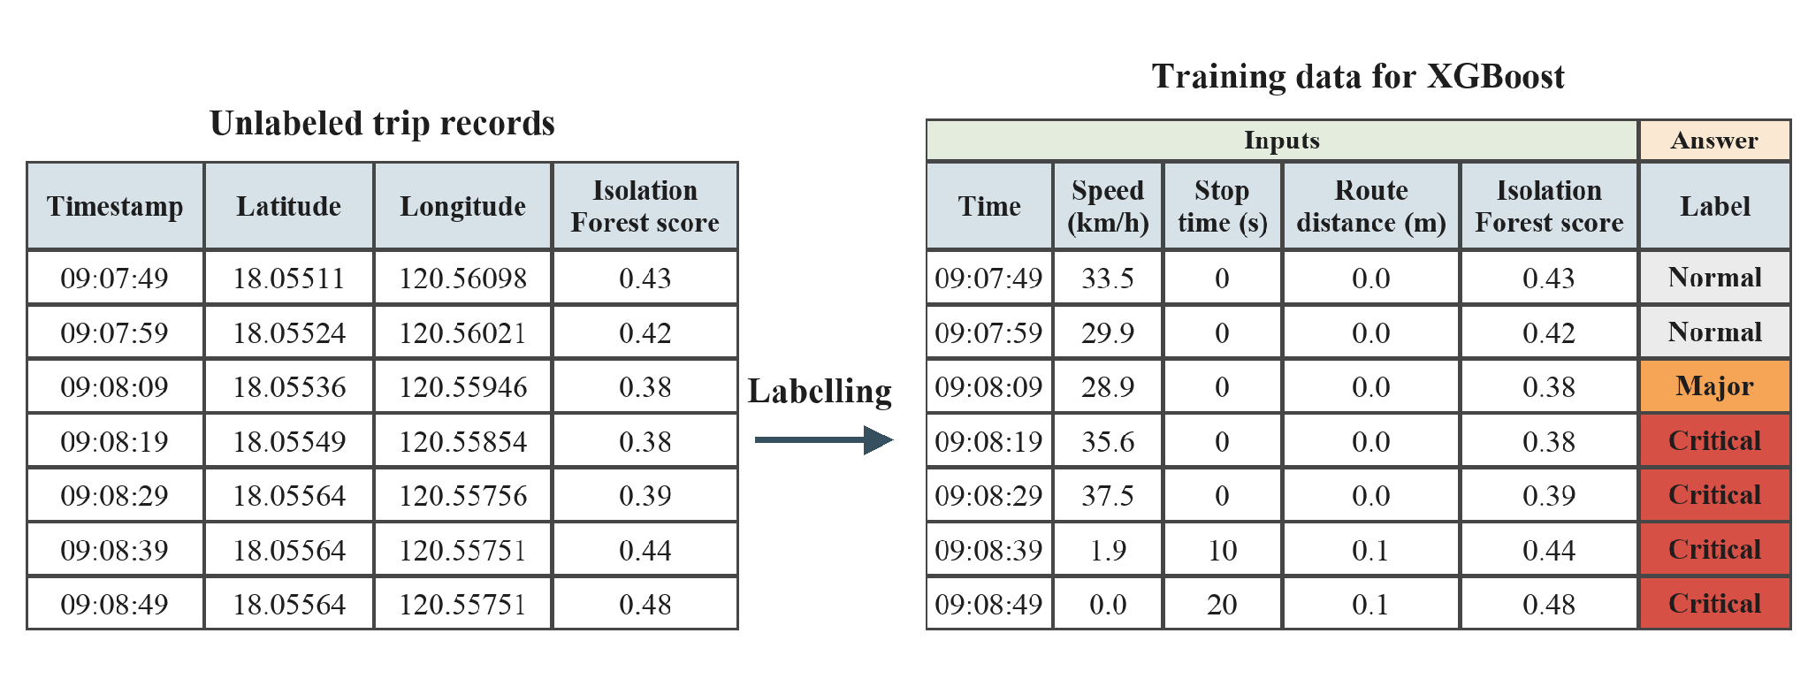
Figure 7. Making labelled data from unlabeled trip records (example rows from one trip in the test data).
The forecast window starts at one minute, because a forecast has to arrive in time for a check-in. In SayfTrip, when a route deviation reaches the critical level, the user has 30 seconds to answer before a message goes to an emergency contact (Edwards & Hosein, 2025), so a window shorter than that would leave no time for that step. No study reviewed gives the best length, so the window is treated as an experiment and compared in Section 3.6.5. A longer window gives more warning, but it may make the forecast less accurate. The labels show what looks unusual compared with earlier trips. They do not show what was dangerous.
3.5.5 Forecasting with XGBoost
XGBoost (Chen & Guestrin, 2016) forecasts the worst concern level in the forecast window from the measures at each moment and the concern level now. It suits tables of measures such as speed and stopping time. The levels are ordered, so the problem is turned into three yes-or-no questions: is the worst level in the forecast window at least Minor, at least Major, and at least Critical? Frank and Hall (2001) show how to combine such answers into an ordered prediction. The three chances are kept in order, so a higher level never gets a higher chance than a lower one. The number of trees is chosen by early stopping on held-out trips. The other settings are kept small for a small data set, with shallow trees and a low learning rate, and are listed with the code. Figure 8 shows the three questions and how the latest earlier trips are held out (Section 3.5.6).
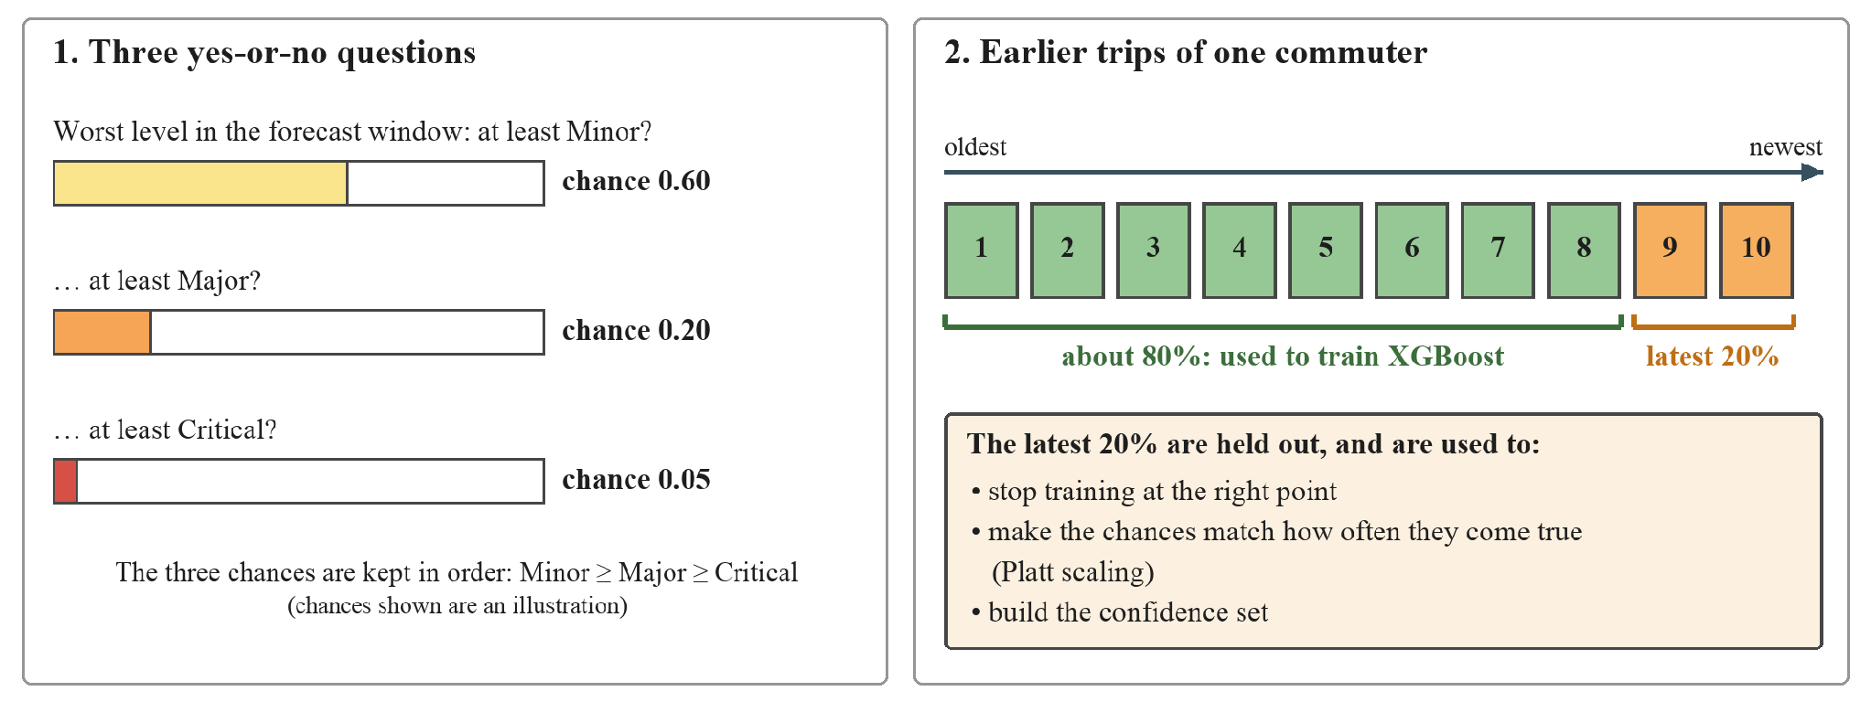
Figure 8. The three yes-or-no questions of XGBoost and the use of the latest 20% of earlier trips (illustrative chances).
3.5.6 Calibration and Confidence
The latest 20% of the history trips, and at least two trips, are held out when the Model is built. Hyndman and Athanasopoulos (2021) say a test set is typically about 20% of the sample, and this study uses the same share as a guide. These trips are used for early stopping, for calibration, and for the confidence sets. Boosted trees tend to give distorted probabilities, and Platt scaling improves them (Niculescu-Mizil & Caruana, 2005), so the chances from the three questions are calibrated with Platt scaling on the held-out trips. Guo et al. (2017) call the gap between confidence and how often a model is right the calibration error, and the study reports it.
The Model also gives a confidence set, which is a short list of levels that contains the true level at a chosen rate. This is split conformal prediction (Angelopoulos & Bates, 2021). The target rate is 90%, a common choice in conformal prediction. The cut-off is taken from the held-out trips.
3.5.7 Keeping the History Recent
Roads, routes, and traffic change, so very old trips may no longer show what is normal. Gama et al. (2013) found that forgetting old data helps a learner follow change, either with a window of recent examples or with weights that fade. The Model uses a window. It learns only from the same commuter's earlier trips that fall inside a chosen number of days before the trip being judged. The best length is not known in advance, so the study tests several lengths (Section 3.6.4).
3.6 Model Evaluation (Objective 3)
3.6.1 Testing Trip by Trip in Date Order
The trips are put in order by start time. Each trip is judged by the Model fitted only on the same commuter's trips before it, and never on another commuter's trips. After it is judged, the trip joins that commuter's history for the next one. A trip is never split between building and judging, because records from the same trip are closely related (Roberts et al., 2017). This is the prequential idea of Gama et al. (2013): each new example is first used to test the model and then to update it. A trip is judged only when at least five earlier trips are available. The study judges this way for the whole recording period. The results are worked out separately for each commuter and then summarised across commuters, with the lowest and highest values shown, so that no single commuter decides the average alone. Figure 9 shows which earlier trips are used in three cases.
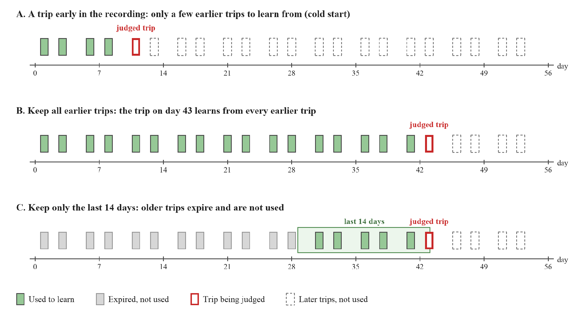
Figure 9. Which earlier trips are used to judge a trip: early in the recording, keeping all earlier trips, and keeping the last 14 days (illustration; not every trip is shown).
3.6.2 Baseline and Noted Events
The forecast is compared with a simple baseline that assumes the current concern level continues. Both are scored with average precision, which rewards ranking real concerns above ordinary moments, for the questions "at least Minor" and "at least Major". The average gap between the forecast level and the true level is also reported. For each of the two questions, the study also reports the share of unusual moments that an alert caught and the share of alerts that were right. For "at least Minor", an alert from the forecast means a chance of at least 0.5 of Minor or worse, and an alert from the baseline means that the current level is Minor or higher.
The notes from the volunteers are used to check the noted events. A noted event counts as flagged if the Model raises an alert from two minutes before to two minutes after the noted time. The window allows for a volunteer's time estimate being rough. It is a starting value, so the study also reports one minute and three minutes. An alert is raised when the forecast chance of a level of Major or worse is at least 0.5, the plain midpoint. This is a starting value, and Section 3.6.5 compares lower limits. The study reports how many noted events were flagged by the forecast and by the current level, and how far ahead the first alert came. Without enough noted events, this check is reported as counts only.
The study also asks whether the forecast gives earlier warning than reacting to the current level. For each trip where both the forecast and the current level reach an alert, it measures how many seconds earlier the forecast alerted. It also counts the trips where both alerted, where only the forecast alerted, and where only the current level reached the alert level. These counts show how often the forecast agrees with the current level and how often it adds or misses something.
3.6.3 History Growth
To show how the Model behaves at the start, the judged trips are grouped by how many earlier trips were in the history, such as 5 to 9, 10 to 19, and so on. For each group, the study reports forecast accuracy against the baseline, calibration error, confidence-set coverage, and false alarms. This is a learning curve in the sense of Silvey and Liu (2024). It also shows the cold-start problem described by Reiss et al. (2024).
3.6.4 History Length
The study compares three history lengths on the same trips: all earlier trips, and only the last 14 or 7 days (see Figure 9 for the 14-day case). For each, it reports the same measures as above. The length with the fewest false alarms and no loss of accuracy is chosen. Cawley and Talbot (2010) warn that settings chosen on the same data used to judge them can look better than they are, so the chosen length is confirmed on new trips recorded after the choice was made.
3.6.5 Checking the Starting Values
Seven starting values have no direct source: the forecast window of one minute, the 100 m stretch length, the strength of 8 trips, the four parts of the day, the 5 earlier trips before the route distance switches from the route line to the earlier trips, the alert limit of 0.5, and the 20% of earlier trips held out for calibration. They are treated as experiments. The study repeats the evaluation with forecast windows of 30 seconds and 2 minutes, with stretch lengths of 50 and 200 m, with strengths of 4 and 16 trips, and with the day split only into night and day or not split at all. For the route distance, it also compares switching after 3 and after 10 earlier trips, and the earlier rule that takes the larger of the distance from the route line and from the earlier trips. It also compares holding out 10% and 30% of the earlier trips, and alert limits from 0.1 to 0.4. The alert limit changes only the alerts and not the accuracy scores, so it is compared by the share of unusual moments caught, the share of alerts that were right, and the false alarms per hour. Changing the forecast window also changes the labels, so the results for different settings are compared by the gain, which is how far the forecast's average precision for Major or worse is above the baseline's, together with the calibration error, the false alarms per hour, and the lead over the current level. If the results change little, the starting values are kept. If they change a lot, the values are re-chosen on the earlier trips only and then confirmed on new trips.
3.6.6 Probabilities and Confidence
The study reports the calibration error for the chance of "at least Minor" and "at least Major". It uses equal-width bins of predicted chance. Guo et al. (2017) use 15 bins, and this study uses 8 so that each bin has enough records with a small data set. It also reports the share of moments for which the confidence set contained the true level, and the average size of the sets, and compares the share with the 90% target.
3.6.7 Alert Episodes and Field False Alarms
Alerts less than one minute apart are grouped into a single episode. The prototype replay reports episodes per trip and per hour of simulated travel. Field false alarms are assessed on trips independently reviewed as having no qualifying movement event. Trips without a review are treated as unverified. This distinction keeps the alert frequency separate from the frequency of false alarms in field use.
3.6.8 Route Familiarization
To show that the Model learns a commuter's usual detours, the study takes the trips that go beyond 150 m of the route line and have at least 20 earlier trips in the same direction. It counts the moments beyond 150 m when the distance is measured from the route line, and when it is measured from the most recent 2, 5, 10 and 20 earlier trips. The fewer moments remain, the better the earlier trips describe the commuter's own paths.
3.6.9 A Fixed Distance Rule for Comparison
The forecast is also compared with a fixed rule that alerts whenever the vehicle is more than 150 m from the route line, which is the first level of the fixed bands in SayfTrip (Edwards & Hosein, 2025). The study counts the alert episodes per trip and per hour for both. It also counts how many long stops and how many episodes beyond 150 m each one flags. A long stop is a finished stop of 40 seconds or more, the length that Sabir et al. (2025) call brief. A rule flags a stop or an episode if it alerts from one minute before it starts to its end. Without trip notes, this comparison shows what each rule watches for, and not which alerts were right.
3.6.10 A Simpler Model for Comparison
XGBoost may be more than a small data set needs, so its forecast is compared with a plain logistic regression. This is a simple method that draws a straight boundary between moments that were followed by an unusual window and moments that were not. It uses a small set of the same inputs: the concern level now, the Isolation Forest score, the stop time and the excess stop time, the time off the route, the distance from the route, the speed, the speed trend, the time since the last stop, the stops in the last minute, and the speed score. It uses the same labels, the same calibration, and the same trips as XGBoost. The comparison asks whether the extra complexity of XGBoost is worth it for the amount of data available.
3.6.11 Other Checks
Three more checks make the results easier to read. The study shows which part of the concern level, the Isolation Forest score, the route distance or the stop length, set each level. It reports the results for each direction of the route. It also measures how long the Model takes to fit on the earlier trips and to score a trip, to see whether it is quick enough to be refitted after every trip.
3.7 Ethical Considerations
Recording trips involves personal data. Under the Data Privacy Act of 2012 (Republic Act No. 10173), consent must be freely given, specific, and informed. Every volunteer is told what is recorded, why, who can see it, and how long it is kept, and signs a consent form before recording. Volunteers can stop at any time and ask for their records to be removed. Riders who share the vehicle are not recorded, because the app saves only the volunteer's own position. Files carry a volunteer code and not a name. The records are stored in the database, which only the researchers can open, and they are kept only as long as the study needs them. The study will ask for approval from a research ethics committee before any recording begins.
Start and end positions can show where a person lives or works. To lower this risk, results are reported for routes and not for people, and the maps in the report show only the public start and end places of a route and never a volunteer's home.
3.8 Summary of Settings
Table 3.1 lists each setting used in this chapter, its value, and where the value comes from. Settings marked as design choices have no source. They are chosen for simplicity, and the study reports them with the results so that they can be reviewed.
Table 3.1 Settings used in the study and their basis
Setting | Value | Basis
Recording interval | 10 seconds | Sabir et al. (2025); Deng et al. (2024); Edwards & Hosein (2025); Bagheri et al. (2020); Mears et al. (2021)
Speed limit for cleaning | 50 m/s | Verma et al. (2024); Land Transportation and Traffic Code (1964)
Acceleration limit | -10 to 10 m/s² | Verma et al. (2024)
Error radius limit | 50 m | Verma et al. (2024)
Trip set aside | more than 1 record in 5 lost, or fewer than 20 records left | Design choice, reported with the results
Stopped speed | below 5 km/h | Sabir et al. (2025)
Route distance levels | 150, 500, and 1,000 m | Edwards & Hosein (2025)
Level cut-offs for forest score and stop time | robust scores of 2.5, 3, and 3.5 | Leys et al. (2013); NIST/SEMATECH (n.d.); Major is the midpoint
Isolation Forest size | 100 trees, samples of 256 | Liu et al. (2008)
Forecast window | starts at 1 minute; 30 seconds and 2 minutes are compared | Experiment. Edwards & Hosein (2025): a 30-second response time means a shorter window leaves no time (Section 3.6.5)
Held-out share of history | latest 20%, at least 2 trips; 10% and 30% are compared | Starting value after Hyndman & Athanasopoulos (2021); experiment (Section 3.6.5)
Confidence set rate | 90% | Angelopoulos & Bates (2021) for the method; 90% is a common choice
Trips per volunteer | at least 60, 30 per direction | Viechtbauer et al. (2015), adapted as a planning example (Section 2.2.6)
Recording period | about 30 days for each volunteer | So that about half of the judged trips come after day 14, when a 14-day window starts to leave out older trips; also gives 60 trips at two a day
History lengths compared | all, 14, and 7 days | Compared in the study (Section 3.6.4)
Road stretch and strength | 100 m and 8 trips | No source; 50 and 200 m, and 4 and 16 trips, are tested (Section 3.6.5)
Earlier trips before the route distance uses them | 5; 3 and 10, and the larger-of-both rule, are compared | Experiment (Section 3.6.5)
Parts of the day | night, morning, midday, afternoon; night and day only, and no split, are compared | Experiment (Section 3.6.5). Night is kept apart because of UN Women (2021)
Fewest earlier trips before judging | 5 | Design choice, reported with the results
Look-back for the measures | 1 minute | Design choice; stays fixed when the forecast window changes
Alert rule | chance of Major or worse of at least 0.5; limits from 0.1 to 0.4 are compared | Plain midpoint as the starting value; experiment (Section 3.6.5)
Alert episode gap | 60 seconds | Starting forecast window; design choice
Event window for noted events | 2 minutes before to 2 minutes after; 1 and 3 minutes also reported | Experiment; reported with the results
Calibration bins | 8 | Guo et al. (2017) use 15; fewer bins suit a small data set

CHAPTER 4
INITIAL RESULTS AND DISCUSSION
4.1 Introduction
This chapter reports the initial evaluation on 60 synthetic trips for one simulated commuter profile. It describes the data and preprocessing, the model’s outputs, and the results of the chronological replay.
Average precision measures how well the forecast ranks windows whose model-derived concern levels later reach the stated threshold. Calibration error measures the gap between forecast probabilities and the observed frequency of those labels. Alert episode counts describe how often the replay issues a flag. Field false-alarm and incident detection rates require independent evidence from real trips.
4.2 The Initial Dataset (Objective 1)
4.2.1 Initial Dataset
The initial dataset covers one simulated commuter profile and one route in both directions. It contains one generated trip in each direction on 30 simulated travel days, for a total of 60 trips and 2,936 location records. The traces cover morning, midday, and afternoon travel. Table 4.1 summarizes the dataset.
Table 4.1. The initial dataset
Item | Value
Simulated commuter profiles | One
Trips | 60 (30 from A to B and 30 from B to A)
Records | 2,936, spaced at 10-second intervals
Simulated date range | 18 August to 8 October 2026 (52 days)
Simulated travel days | 30, with one trip in each direction on each day
Time of day | 29 trips in the morning (7:00 to 9:59), 3 at midday, 28 in the afternoon (14:00 to 17:59), none at night
Length of a trip | 8 minutes on average (from 5.5 to 11.2 minutes)
Distance of a trip | 2.6 km on average (from 2.2 to 3.6 km)
Speed while moving | Middle value 25.5 km/h (most records between 16 and 33 km/h)
Records with the vehicle stopped | 24%
Stops | 200 stops during the trips, about 3 per trip. The middle length is 30 seconds and the longest is 90 seconds. Each trip also starts with the vehicle standing still for 10 seconds.

4.2.2 Cleaning
No record broke the speed limit of 50 m/s or the acceleration limit, and there were no repeated times or unreadable rows. The file has no accuracy column, so the limit on the error radius was not used. No trip was set aside. The fastest speed in the data was 41 km/h, which is about 11 m/s and far below the 50 m/s limit, so the speed rule had nothing to remove. The cleaning rules therefore removed nothing from this dataset. To check that the rules work, a jump of about 15 km was added to a copy of one trip, and the speed rule removed that one record. This check was made on a copy and is not part of the dataset.
4.2.3 Trips That Leave the Route
The vehicles do not always stay on the route line. Of the 60 trips, 26 stayed within 150 m of the line all the time, and 34 went beyond 150 m at least once. An episode is one continuous stretch of time. An episode away from the route starts when the vehicle goes beyond 150 m of the route line and ends when it is back within 150 m. Together the 34 trips had 41 such episodes. An episode lasted from 10 to 140 seconds, with a middle value of 60 seconds. The largest distance was 393 m. This is in the Minor band (150 to 500 m), so no trip reached the Major band (500 to 1,000 m) or the Critical band.
Figure 10 shows two trips. Trip 17 stays within the limit. Trip 36 leaves the limit twice and returns each time. These departures happen in more than half of the trips, so for this commuter they are part of normal travel.
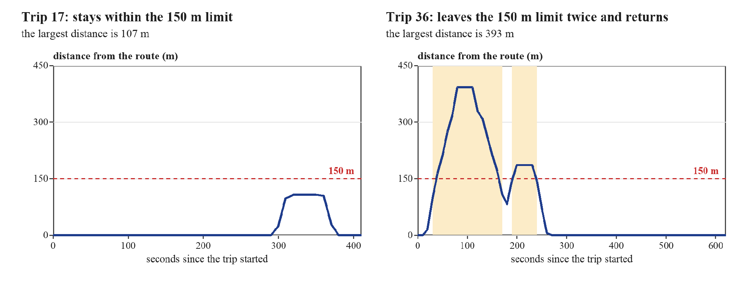
Figure 10. Distance from the route line over time for two trips (the shaded parts are beyond 150 m).
4.2.4 Route Familiarization
A commuter who takes the same detour again and again is doing nothing unusual. The Model handles this in the distance from the route. While the commuter has fewer than 5 earlier trips in a direction, the distance is measured from the route line. After that, it is measured from the commuter’s own earlier trips. Figure 11 shows the 30 trips from A to B. Most follow the route line, but several take the same few other paths, in the town near A and around the campus near B.
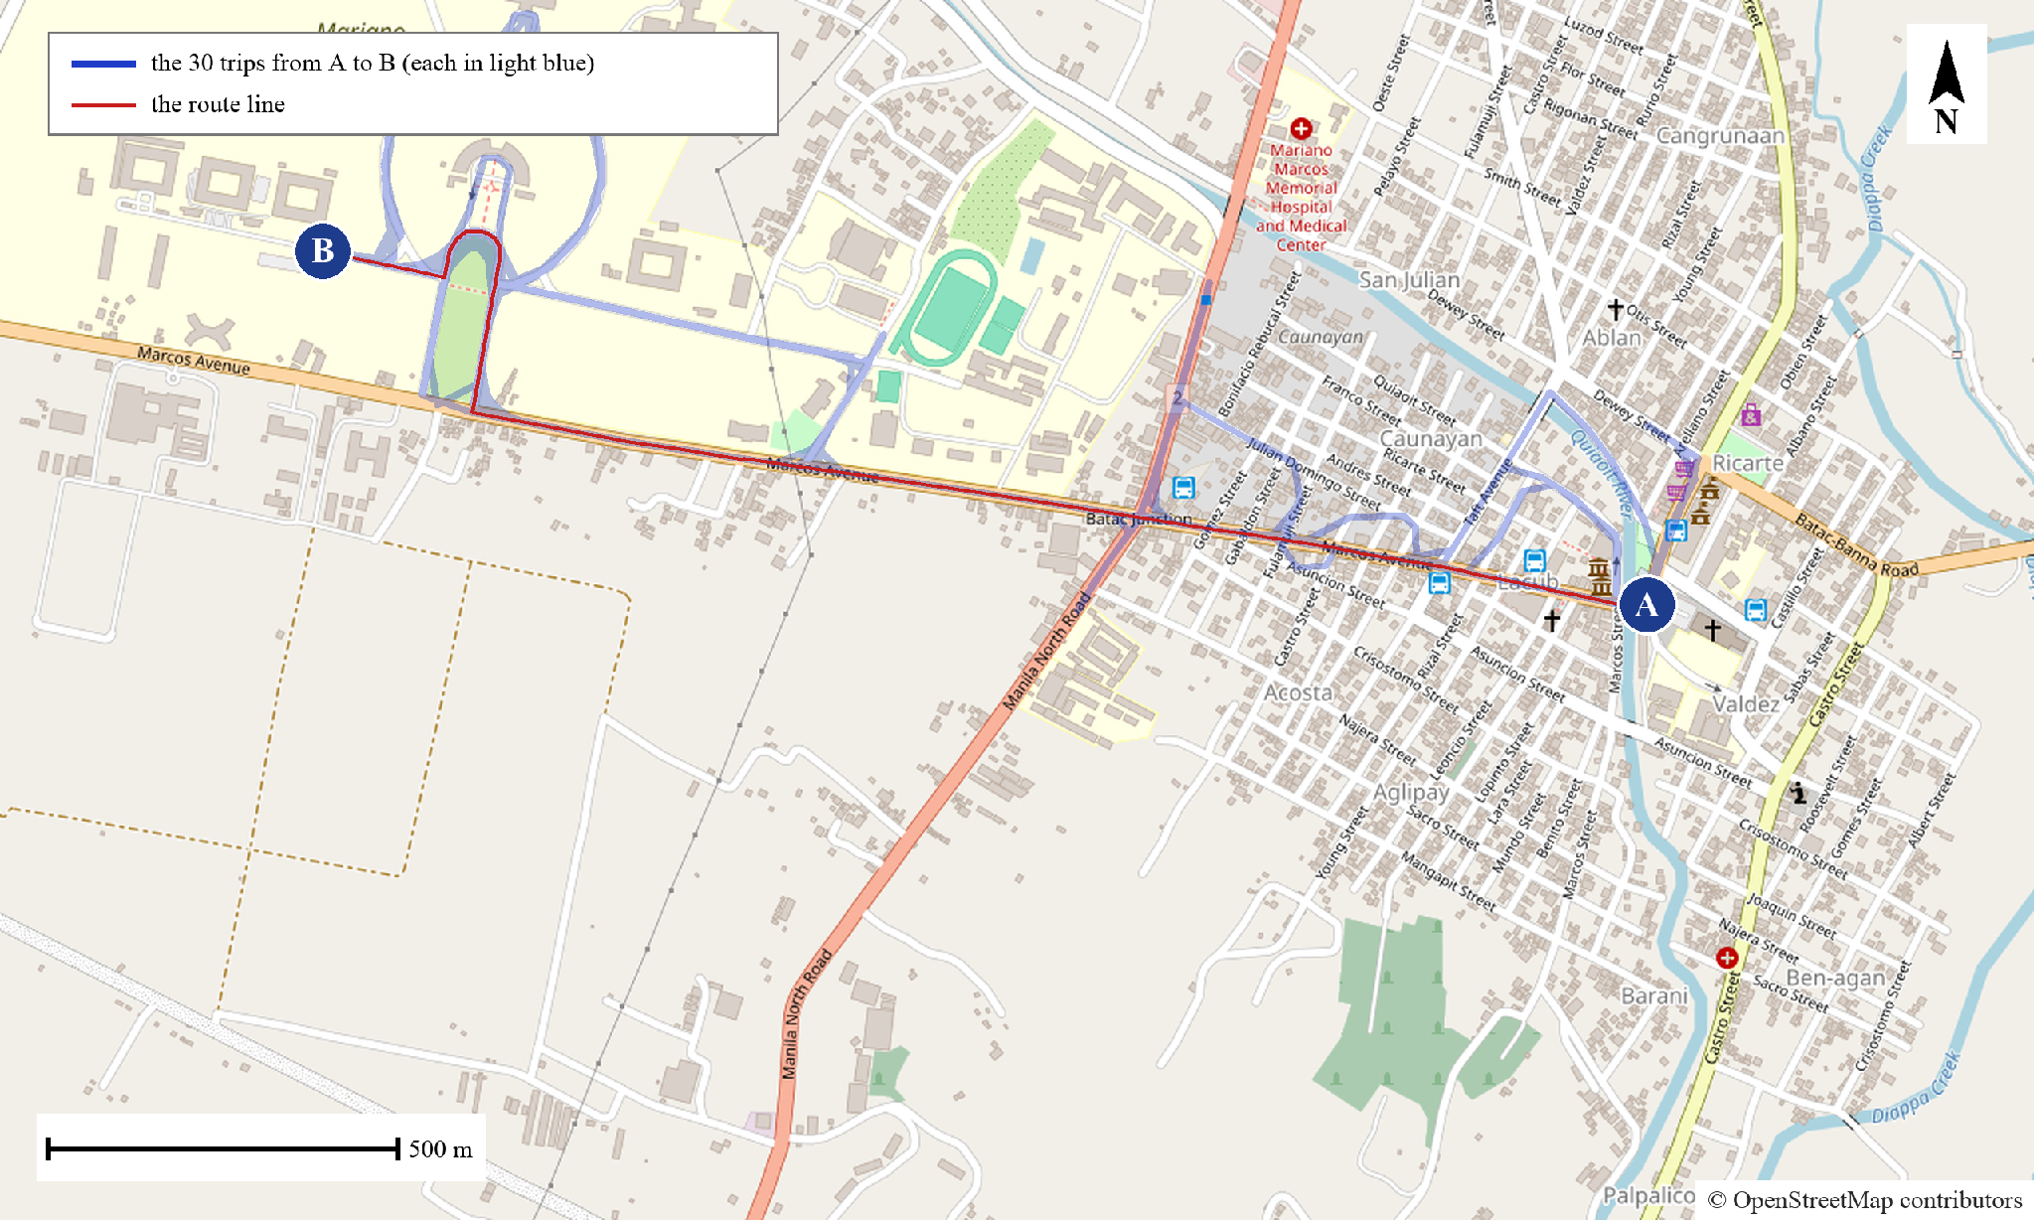
Figure 11. The 30 trips from A to B on the map, with the route line. Map data © OpenStreetMap contributors.
Table 4.2 shows what the earlier trips do. It uses the 11 trips that leave the 150 m limit and have at least 20 earlier trips in the same direction. Measured from the route line, these trips had 106 moments beyond 150 m. With only 2 earlier trips as the history, 56 moments were still beyond 150 m. With 5 earlier trips there were 18, and with 20 earlier trips only 7. This means that 83% of the moments away from the route line were already familiar after 5 earlier trips, and 93% after 20. The commuter’s usual detours stop counting as off-route once there is enough history.
Table 4.2. Moments beyond 150 m when the distance is measured from different histories
Distance measured from | Moments beyond 150 m | Share of the moments beyond the route line
The route line | 106 | 100%
2 earlier trips | 56 | 53%
5 earlier trips | 18 | 17%
10 earlier trips | 12 | 11%
20 earlier trips | 7 | 7%

4.3 The Model on the Initial Data (Objective 2)
4.3.1 Concern Levels
The Model gave every moment of every judged trip a concern level. Table 4.3 shows how often each level occurred. Most moments were Normal. The label of a moment is the worst level in the next minute, so labels reach higher levels more often than the levels at the moments themselves.
Table 4.3. Concern levels of the 2,727 judged moments
Level | Moments at that level now | Moments with that level as the label
Normal | 2,532 (93%) | 2,258 (83%)
Minor | 110 (4%) | 214 (8%)
Major | 41 (2%) | 106 (4%)
Critical | 44 (2%) | 149 (5%)

4.3.2 What Sets the Levels
The level of a moment is the highest of three parts: the Isolation Forest score, the distance from the route, and the length of the current stop. Table 4.4 shows which part reached the level. A moment is counted under more than one column when two parts reach the same level. Route distance reached only Minor, because no trip went beyond 500 m. The Major and Critical levels therefore came from the Isolation Forest score and from long stops, in about equal parts.
Table 4.4. The part that set the concern level
Level now | Moments | Isolation Forest score | Distance from the route | Stop length
Minor | 110 | 41% | 38% | 25%
Major | 41 | 49% | 0% | 51%
Critical | 44 | 39% | 0% | 61%

4.3.3 A Worked Trip
Figure 12 follows Trip 36 from start to end. The Model judged this trip using only the 35 trips recorded before it. The vehicle began to move away from the route at about 20 seconds and passed the 150 m limit at about 40 seconds, when the concern level rose to Minor. When the vehicle stopped at about 90 seconds, the level rose to Major and then to Critical. The level returned to Normal after the vehicle came back to within 150 m of the route.
The forecast did well in one way and badly in two. The chance of Minor or worse rose from 0.02 at 20 seconds to 0.40 at 30 seconds, ten seconds before the level itself rose, and it passed 0.5 at 50 seconds. But the chance of Major or worse stayed at zero during the whole first departure, even when the level was already Critical. Near the end of the trip, the vehicle stopped at about 450 seconds and the chance of Major or worse rose above 0.5. The stop ended before it became long, so Major was never reached and this alert did not match the model-derived Major threshold.
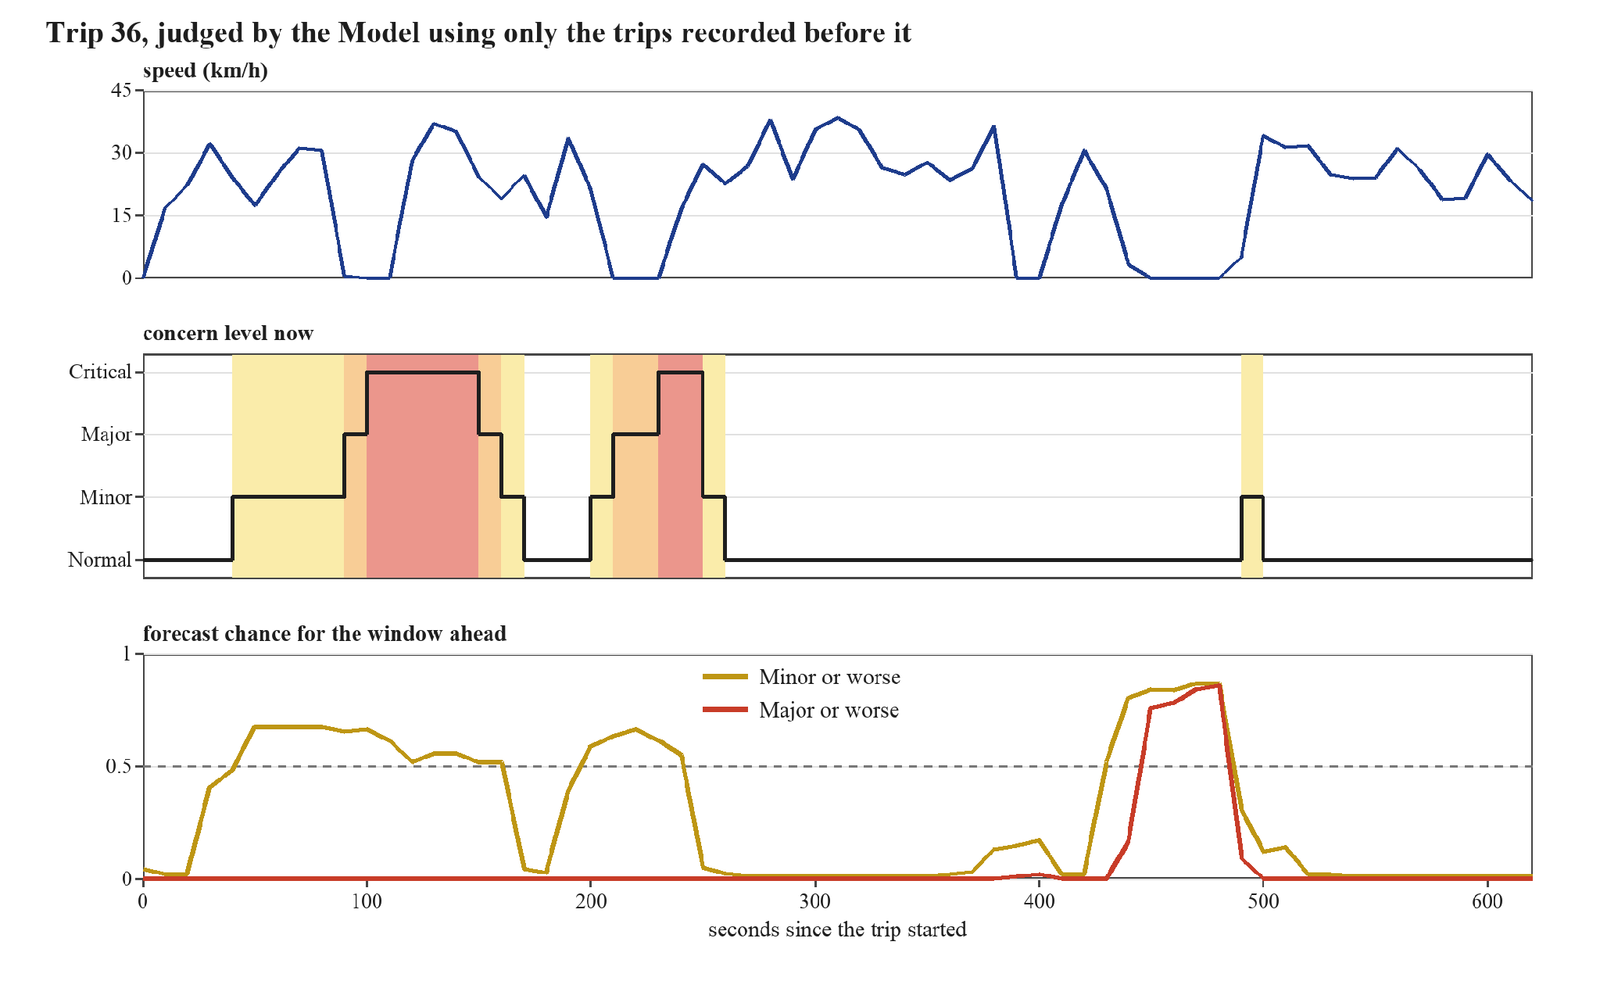
Figure 12. Trip 36: speed, the concern level now, and the forecast chances for the window ahead.
4.4 Evaluation Results (Objective 3)
The trips were judged in date order, each one using only the trips recorded before it. The first five trips were only used as history, so 55 trips and 2,727 moments were judged. Unless a section says otherwise, the Model kept all earlier trips, and the forecast window was one minute.
4.4.1 The Forecast Compared with the Baseline
The baseline assumes that the current concern level continues. Table 4.5 compares it with the forecast. An alert from the forecast means a chance of at least 0.5. An alert from the baseline means that the current level is at or above the level in question.
Table 4.5. The forecast compared with the baseline
Measure | Forecast | Baseline
Average precision, Minor or worse (higher is better) | 0.50 | 0.34
Average precision, Major or worse (higher is better) | 0.30 | 0.20
Minor or worse: share of moments the alert caught | 46% | 30%
Minor or worse: share of alerts that were right | 58% | 73%
Major or worse: share of moments the alert caught | 19% | 21%
Major or worse: share of alerts that were right | 41% | 62%
Average gap to the true level (lower is better) | 0.36 | 0.28
Alert episodes per trip | 0.58 | 0.58
Alert episodes per hour of travel | 4.2 | 4.2

The forecast ranks Minor-or-higher and Major-or-higher moments better than the baseline. For Minor or worse, it catches more moments (46% against 30%), with lower alert precision. At the 0.5 alert threshold for Major or worse, it catches about the same share as the baseline, with lower precision. Both methods produce about 0.58 alert episodes per trip, or about four per hour of simulated travel.
The stated chances can be trusted fairly well. The calibration error was 0.05 for Minor or worse and 0.03 for Major or worse, which means the chances are off by only a few points on average. The confidence sets are meant to hold the true level 90% of the time. They held it 86% of the time, a little under the target, and each set had 1.2 levels on average.
4.4.2 Warning Ahead of the Current Level
A forecast is useful only if it warns earlier than simply waiting for the current level to rise. Table 4.6 compares the two in the trips where an alert for Major or worse occurred.
Table 4.6. Alerts from the forecast and from the current level (Major or worse)
Result | Trips
Both alerted | 18
Only the forecast alerted | 11
Only the current level reached Major or worse | 11
Where both alerted: the forecast alerted first | 78% of the 18 trips
Where both alerted: the middle lead of the forecast | 40 seconds

In the 18 trips where both alerted, the forecast came first in 14 of them, with a middle lead of 40 seconds. This is the best result for the forecast. The other rows show its weak side. In 11 trips only the current level reached Major, so the forecast missed them. In 11 trips only the forecast alerted, so those alerts were not followed by a Major level. Over all the judged moments, the forecast alerted in only 15% of the 85 moments where the current level was already Major or worse.
4.4.3 How the Model Behaves as the History Grows
At the start, the Model has few earlier trips to learn from. Table 4.7 groups the judged trips by the number of earlier trips in the history. Figure 13 shows the same results as bars.
Table 4.7. Results by the number of earlier trips in the history
Earlier trips | Trips judged | Average precision, forecast | Average precision, baseline | Calibration error | Confidence set held the true level | Alert episodes per trip
5–9 | 5 | 0.53 | 0.32 | 0.08 | 79% | 0.60
10–19 | 10 | 0.39 | 0.26 | 0.08 | 82% | 1.00
20–29 | 10 | 0.37 | 0.08 | 0.04 | 87% | 0.50
30–39 | 10 | 0.30 | 0.20 | 0.06 | 87% | 0.90
40+ | 20 | 0.16 | 0.20 | 0.02 | 89% | 0.25

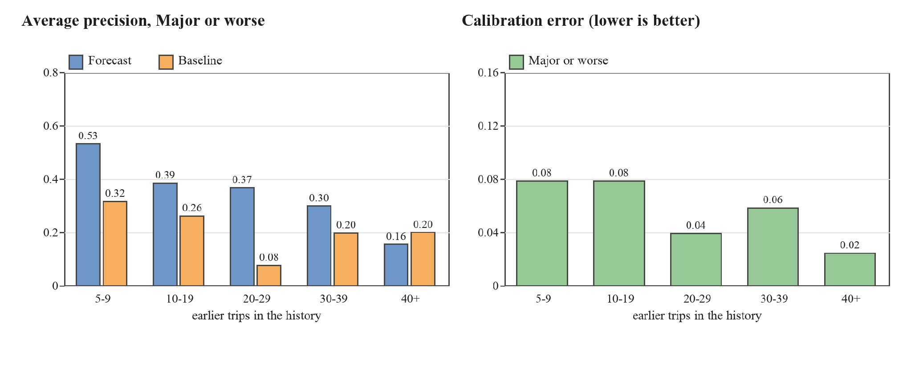
Figure 13. Average precision and calibration error by the number of earlier trips in the history (Major or worse).
The stated chances became more trustworthy as the history grew. The calibration error fell from 0.08 with 5 to 9 earlier trips to 0.02 with 40 or more, and the confidence sets came close to the 90% target in the last group (89%). The forecast ranked better than the baseline in the first four groups. In the last group, with 40 or more earlier trips, the baseline was ahead (0.20 against 0.16). The groups are small, from 5 to 20 trips, so these differences are rough and should not be over-read.
4.4.4 How Long the History Is Kept
The Model can keep all earlier trips or only the recent ones. Table 4.8 compares keeping all of them with keeping only the last 14 days or the last 7 days.
Table 4.8. Results for different history lengths
History kept | Earlier trips used (average) | Average precision, Minor or worse | Average precision, Major or worse | Calibration error, Major or worse | Alert episodes per trip | Alert episodes per hour
All earlier trips | 32.0 | 0.50 | 0.30 | 0.03 | 0.58 | 4.2
Last 14 days | 13.8 | 0.50 | 0.33 | 0.04 | 0.51 | 3.7
Last 7 days | 7.2 | 0.60 | 0.37 | 0.04 | 0.40 | 2.9

The results are mixed, and a shorter history is not clearly worse. Alert episodes fell as the history got shorter (0.58, 0.51 and 0.40 per trip), and the ranking of Major or worse stayed the same or improved (0.30, 0.33 and 0.37). The trips in this dataset do not change over time, so this dataset cannot show whether old trips become misleading. The choice has to be made with more trips.
4.4.5 Starting Values That Were Tested
Some settings have no direct source, so they were treated as experiments. Table 4.9 shows what happened when each was changed. The “gain” is the forecast’s average precision for Major or worse minus the baseline’s. A larger gain means that the forecast beats the baseline by more. The last column is the share of moments whose label is Minor or worse.
Table 4.9. Results when the starting values are changed
Setting | Average precision, forecast | Average precision, baseline | Gain | Calibration error | Alert episodes per hour | Middle lead (seconds) | Labels Minor or worse
Forecast window 30 seconds | 0.32 | 0.24 | 0.08 | 0.02 | 4.2 | 20 | 11%
Forecast window 60 seconds (starting value) | 0.30 | 0.20 | 0.10 | 0.03 | 4.2 | 40 | 17%
Forecast window 120 seconds | 0.29 | 0.22 | 0.07 | 0.06 | 3.6 | 70 | 27%
Road stretch 50 m | 0.36 | 0.24 | 0.12 | 0.03 | 4.2 | 40 | 18%
Road stretch 100 m (starting value) | 0.30 | 0.20 | 0.10 | 0.03 | 4.2 | 40 | 17%
Road stretch 200 m | 0.30 | 0.21 | 0.09 | 0.03 | 3.8 | 45 | 18%
Strength 4 trips | 0.33 | 0.21 | 0.12 | 0.04 | 4.4 | 40 | 18%
Strength 8 trips (starting value) | 0.30 | 0.20 | 0.10 | 0.03 | 4.2 | 40 | 17%
Strength 16 trips | 0.35 | 0.22 | 0.13 | 0.03 | 4.5 | 40 | 17%
Four parts of the day (starting value) | 0.30 | 0.20 | 0.10 | 0.03 | 4.2 | 40 | 17%
Day and night only | 0.35 | 0.22 | 0.13 | 0.03 | 4.1 | 40 | 17%
No split by time of day | 0.35 | 0.22 | 0.13 | 0.03 | 4.1 | 40 | 17%
Earlier trips held out: 10% | 0.33 | 0.20 | 0.13 | 0.03 | 4.0 | 40 | 17%
Earlier trips held out: 20% (starting value) | 0.30 | 0.20 | 0.10 | 0.03 | 4.2 | 40 | 17%
Earlier trips held out: 30% | 0.31 | 0.20 | 0.11 | 0.04 | 4.8 | 40 | 17%
Route distance: the larger of the line and earlier trips | 0.30 | 0.20 | 0.10 | 0.04 | 4.4 | 40 | 27%
Route distance: earlier trips after 3 trips | 0.29 | 0.20 | 0.09 | 0.04 | 4.4 | 40 | 16%
Route distance: earlier trips after 5 trips (starting value) | 0.30 | 0.20 | 0.10 | 0.03 | 4.2 | 40 | 17%
Route distance: earlier trips after 10 trips | 0.30 | 0.20 | 0.10 | 0.04 | 4.2 | 40 | 19%

A longer forecast window gives more warning. The middle lead was 20, 40 and 70 seconds for windows of 30, 60 and 120 seconds. The gain stayed between 0.07 and 0.10, but the calibration error was larger for the longest window (0.02, 0.03 and 0.06). The one-minute window is a middle choice between warning time and the trust that can be placed in the chances. The road stretch and the strength changed the results only a little, so the starting values for those two were kept.
The split by time of day did not help. With four parts of the day the gain was 0.10, and with no split it was 0.13. The trips fall in only two parts, morning and afternoon, so the split cut the history of each part in half. The day-and-night version is the same as no split here, because no trip was recorded at night. This dataset therefore cannot show whether time of day matters, and the split is kept as an option until there are trips at other times, especially at night.
The rule for the route distance made a clear difference to the labels. With the earlier rule, which took the larger of the distance from the route line and from earlier trips, 27% of the moments had a label of Minor or worse. With the starting rule it was 17%, because the commuter’s usual detours no longer counted. The results for Major or worse hardly changed (gain 0.10 and 0.10), and the alert episodes stayed close (0.60 and 0.58 per trip). The reason is that Major and Critical never came from route distance in this dataset (Table 4.4).
The share of earlier trips held out for calibration also made a small difference. Holding out 10% instead of 20% raised the average precision for Major or worse from 0.30 to 0.33 and lowered the alert episodes from 4.2 to 4.0 per hour. Holding out 30% gave 0.31. The Model has little data, so giving more of it to training helps a little.
Table 4.10 shows how lowering the alert threshold from 0.5 changes the replay results for Major or worse. At 0.3, the forecast catches 40% of windows with a Major-or-higher label, and 42% of the flagged windows have that label. Alert frequency rises from about four to about seven episodes per hour. The comparison shows how changing the cutoff affects agreement with the model-derived labels and the frequency of alerts.
Table 4.10. The alert limit for Major or worse
Alert limit (chance of Major or worse) | Share of Major or worse moments caught | Share of alerts that were right | Alert episodes per hour
0.5 (starting value) | 19% | 41% | 4.2
0.4 | 31% | 43% | 6.2
0.3 | 40% | 42% | 6.7
0.2 | 50% | 40% | 8.6
0.1 | 60% | 32% | 9.2

4.4.6 A Fixed Distance Rule for Comparison
A fixed rule is a simple alternative. It raises an alert whenever the vehicle is more than 150 m from the route line, which is the first level of the fixed bands used in SayfTrip (Edwards & Hosein, 2025). Table 4.11 compares it with the forecast of Major or worse over the 55 judged trips. A long stop is a finished stop of 40 seconds or more, the length that Sabir et al. (2025) call brief. A rule counts as flagging a stop or a detour if it alerts from one minute before it starts to its end.
Table 4.11. A fixed distance rule and the forecast of Major or worse
Measure | Fixed 150 m rule | Forecast of Major or worse
Alert episodes per trip | 0.69 | 0.58
Alert episodes per hour of travel | 5.0 | 4.2
Trips with at least one alert | 32 of 55 | 29 of 55
Long stops flagged (56 stops) | 6 (11%) | 28 (50%)
Episodes beyond 150 m flagged (39 episodes) | 39 (100%) | 6 (15%)

The number of alerts is about the same, but the alerts are for different things. The fixed rule alerts on every detour, including the routine ones, and it flagged only 6 of the 56 long stops, and only by chance when a stop fell inside a detour. The Model flagged 28 of the long stops and 6 of the 39 detours. Its alerts for detours are fewer because most detours are familiar. There are no trip notes yet, so this does not show which alerts were right. It shows that the Model watches for stops as well as for detours, and that it does not alert on every usual detour.
4.4.7 A Simpler Model for Comparison
XGBoost may be more than this amount of data needs. As a check, the forecast was also made with a plain logistic regression, which is a simple method that uses a few of the same inputs and the same labels. Table 4.12 compares the two on the same trips.
Table 4.12. The Model (XGBoost) and a plain logistic regression
Measure | XGBoost (the Model) | Logistic regression
Average precision, Minor or worse | 0.50 | 0.49
Average precision, Major or worse | 0.30 | 0.34
Minor or worse: share of moments the alert caught | 46% | 25%
Major or worse: share of moments the alert caught | 19% | 13%
Major or worse: share of alerts that were right | 41% | 56%
Alerts when the current level was already Major or worse | 15% | 25%
Calibration error, Major or worse | 0.03 | 0.03
Alert episodes per hour | 4.2 | 3.2
Middle lead over the current level (seconds) | 40 | 20

For Major or worse, the simple model ranked the moments better (0.34 against 0.30), had more of its alerts right, and had fewer alert episodes. XGBoost was better for Minor or worse, where it caught 46% of the moments against 25%, and it warned earlier (a middle lead of 40 seconds against 20). With only 60 trips, XGBoost has no clear advantage for the rare Major or worse moments. Its advantage is in the more common Minor moments and in earlier warning. These results come from the same trips that were used to compare the settings, so they should be confirmed on new trips.
4.4.8 Results by Direction and Running Time
Table 4.13 shows the results for each direction. They are alike in the number of alert episodes. The forecast beat the baseline in both directions.
Table 4.13. Results by direction (Major or worse)
Direction | Trips judged | Average precision, forecast | Average precision, baseline | Alert episodes per trip | Alert episodes per hour
A to B | 27 | 0.25 | 0.17 | 0.59 | 4.5
B to A | 28 | 0.37 | 0.23 | 0.57 | 4.0

The Model is quick. Fitting it on the earlier trips took about 0.25 seconds (at most 0.48), and scoring a whole trip took about 0.02 seconds (at most 0.04) on the researcher’s computer. This is small enough to refit the Model after every trip.
4.4.9 Noted Unusual Events
This check could not be made yet, because no trip notes have been collected. The count of noted events flagged by the Model, and the false alarms on trips with no noted event, are left for the next results. The tool that reads the notes is ready. As a check, one stop of about 140 seconds was added to a copy of a trip with a note. The Model flagged it, and the forecast alerted 80 seconds before the noted time. This was only a check of the tool and is not a result.
4.5 Discussion
The first question asked how the trips can be recorded, cleaned, and turned into measures. This worked. The 60 trips had no data errors, and the measures of speed, stopping, and distance from the route could be worked out for every moment. The data showed three things that matter for the Model. The vehicle stopped for about a quarter of the records, it left the route line for a short while in more than half of the trips, and it took the same few other paths again and again. A fixed rule would treat many ordinary trips as unusual.
The second question asked how an Isolation Forest and XGBoost can be used together. The whole pipeline ran from the records to a forecast for every moment. The concern levels were sensible: most moments were Normal, and the higher levels came with unexpected stops and unfamiliar detours. The route distance learned the commuter’s usual detours quickly: after 5 earlier trips, 83% of the moments away from the route line were familiar. The forecast of Minor or worse worked well and sometimes warned before the current level rose. The forecast of Major or worse was weak. Its chance often stayed near zero when the current level was already Major or Critical, and it alerted in only 15% of those moments. Major and Critical moments are rare in these data (about 3% of the moments, and 9% of the labels). For a typical trip, XGBoost had only about 70 Major or worse moments to learn from. Changing its settings did not help, and a plain logistic regression ranked Major or worse better (Table 4.12). The weakness therefore comes from the small amount of data and not from a fault in the method.
The forecast modestly improves average precision over the persistence baseline. At the 0.5 threshold for Major or worse, it provides no improvement in recall. The prediction sets contain the model-derived level 86% of the time, below the 90% target. The replay produces about 0.58 alert episodes per trip, or about four per hour. The comparison with the fixed-distance rule shows that the methods flag different movement patterns at a similar frequency.
In this replay, the forecast alerts a median of 40 seconds before the current level among the trips where both methods alert and the forecast leads. The model also learns frequently used detours in the synthetic traces. Splitting the history by time of day did not help, and the baseline caught up when 40 or more earlier trips were available. These results describe the simulated route and call for confirmation with independent field trips.
The synthetic traces contain no independently documented commuter incidents. Long stops and detours can have ordinary causes. A separate field evaluation using independently documented trip events is needed to assess how often the model’s flags match events that warrant attention.
4.6 Limitations and Next Steps
The results come from 60 synthetic trips on one route and include no night trips. The groups used for the history curve are small. Many settings were compared on the same trips, so a value that looks best here may be fitted to these trips by chance (Cawley & Talbot, 2010). Any setting selected using this replay needs evaluation on separate trips. Agreement with independently documented field events remains to be evaluated.
Field evaluation would extend the analysis to multiple commuters, routes, vehicle types, and times of day. Independently documented trip notes would provide event times and descriptions for comparing alerts with observed movement events.

References
Agapito, T. I. S., Sevillano, G. M. M., Alfonso, E. A. M., Lopez, L. C. R., Sevilla, A. B. G., & Ramos, J. C. A. (2025). Pathfinders: A public commuters' and parents' safety and assistance application. UE Research Journal, 27, 94–121.
Angelopoulos, A. N., & Bates, S. (2021). A gentle introduction to conformal prediction and distribution-free uncertainty quantification. arXiv. https://arxiv.org/abs/2107.07511
Ankunda, G., & Venter, C. (2025). Studying transfers in informal transport networks using volunteered GPS data. Travel Behaviour and Society, 39, Article 100936. https://doi.org/10.1016/j.tbs.2024.100936
Bagheri, M., Mladenović, M. N., Kosonen, I., Nurminen, J. K., Roncoli, C., & Ylä-Jääski, A. (2020). A computational framework for revealing competitive travel times with low-carbon modes based on smartphone data collection. Journal of Advanced Transportation, 2020, Article 4693750. https://doi.org/10.1155/2020/4693750
Bakker, S., Ma, Y., & Mohammadi Ziabari, S. S. (2025). Exploring a hybrid deep learning approach for anomaly detection in mental healthcare provider billing: Addressing label scarcity through semi-supervised anomaly detection. arXiv. https://arxiv.org/abs/2507.01924
Baluan, A. R. E. L., Aguilar, A., Briones, N. C., Agustin, J., Bartolome, M. A. F., Ganitano, M. C. A., Ruiz, J. B., & Valencia, C. A. (2026). Pesopasada: A study on the impact of fuel pricing on jeepney and tricycle drivers in Sarrat, Ilocos Norte [Conference paper]. DLSU Senior High School Research Congress. https://animorepository.dlsu.edu.ph/conf_shsrescon/2026/BoA_SPL/9
Cawley, G. C., & Talbot, N. L. C. (2010). On over-fitting in model selection and subsequent selection bias in performance evaluation. Journal of Machine Learning Research, 11, 2079–2107. https://jmlr.org/papers/v11/cawley10a.html
Chen, C., Zhang, D., Castro, P. S., Li, N., Sun, L., Li, S., & Wang, Z. (2013). iBOAT: Isolation-based online anomalous trajectory detection. IEEE Transactions on Intelligent Transportation Systems, 14(2), 806–818.
Chen, T., & Guestrin, C. (2016). XGBoost: A scalable tree boosting system. In Proceedings of the 22nd ACM SIGKDD International Conference on Knowledge Discovery and Data Mining (pp. 785–794). https://doi.org/10.1145/2939672.2939785
Chen, X., Cui, T., Fu, J., Peng, J., & Shan, J. (2016). Trend-residual dual modeling for detection of outliers in low-cost GPS trajectories. Sensors, 16(12), Article 2036. https://doi.org/10.3390/s16122036
Corpuz, R. R. N., Cabrera, C. P., Tuazon, A. R., & Pangilinan, A. J. A. (2023). Public sexual harassment in public transportation in Pampanga. EPRA International Journal of Multidisciplinary Research, 9(11), 320–328. https://doi.org/10.36713/epra14837
Cvach, M. (2012). Monitor alarm fatigue: An integrative review. Biomedical Instrumentation & Technology, 46(4), 268–277.
Data Privacy Act of 2012, Republic Act No. 10173 (2012). https://lawphil.net/statutes/repacts/ra2012/ra_10173_2012.html
Deng, J., Pang, J., Xu, J., & Yu, H. (2024). Unsupervised abnormal stop detection for long distance coaches with low-frequency GPS. arXiv. https://arxiv.org/abs/2411.04422
Djon, D., Jhawar, J., Drumm, K., & Tran, V. (2023). A comparative analysis of multiple methods for predicting a specific type of crime in the city of Chicago. arXiv. https://arxiv.org/abs/2304.13464
Edwards, K., & Hosein, P. (2025). A self-contained spatio-temporal anomaly detection application for travel safety. In 2025 IEEE International Conference on Technology Management, Operations and Decisions (ICTMOD) (pp. 1–6). IEEE. https://doi.org/10.1109/ICTMOD66732.2025.11371875
Etikan, I., Musa, S. A., & Alkassim, R. S. (2016). Comparison of convenience sampling and purposive sampling. American Journal of Theoretical and Applied Statistics, 5(1), 1–4. https://doi.org/10.11648/j.ajtas.20160501.11
Frank, E., & Hall, M. (2001). A simple approach to ordinal classification. In Machine learning: ECML 2001 (pp. 145–156). Springer. https://doi.org/10.1007/3-540-44795-4_13
Gama, J., Sebastião, R., & Rodrigues, P. P. (2013). On evaluating stream learning algorithms. Machine Learning, 90(3), 317–346. https://doi.org/10.1007/s10994-012-5320-9
Gama, J., Žliobaitė, I., Bifet, A., Pechenizkiy, M., & Bouchachia, A. (2014). A survey on concept drift adaptation. ACM Computing Surveys, 46(4), Article 44. https://doi.org/10.1145/2523813
Gibbs, I., & Candès, E. (2021). Adaptive conformal inference under distribution shift. In Advances in Neural Information Processing Systems 34. https://arxiv.org/abs/2106.00170
GPS.gov. (n.d.). GPS accuracy. U.S. Government. https://www.gps.gov/gps-accuracy
Guo, C., Pleiss, G., Sun, Y., & Weinberger, K. Q. (2017). On calibration of modern neural networks. In Proceedings of the 34th International Conference on Machine Learning. https://arxiv.org/abs/1706.04599
Hariri, S., Carrasco Kind, M., & Brunner, R. J. (2021). Extended isolation forest. IEEE Transactions on Knowledge and Data Engineering. https://arxiv.org/abs/1811.02141
Hofmockel, J., & Sax, E. (2018). Isolation Forest for anomaly detection in raw vehicle sensor data. In Proceedings of the 4th International Conference on Vehicle Technology and Intelligent Transport Systems (pp. 411–416). SCITEPRESS. https://doi.org/10.5220/0006758004110416
Hyndman, R. J., & Athanasopoulos, G. (2021). Forecasting: Principles and practice (3rd ed.). OTexts. https://otexts.com/fpp3/
Kansal, S. (2020, January 9). RideCheck: Connecting you with help when you need it. Uber Newsroom. https://www.uber.com/en-IN/newsroom/ridecheck-india
Land Transportation and Traffic Code, Republic Act No. 4136 (1964). https://lawphil.net/statutes/repacts/ra1964/ra_4136_1964.html
Leys, C., Ley, C., Klein, O., Bernard, P., & Licata, L. (2013). Detecting outliers: Do not use standard deviation around the mean, use absolute deviation around the median. Journal of Experimental Social Psychology, 49(4), 764–766. https://doi.org/10.1016/j.jesp.2013.03.013
Li, P., Abdel-Aty, M., & Yuan, J. (2021). Using bus critical driving events as surrogate safety measures for pedestrian and bicycle crashes based on GPS trajectory data. Accident Analysis & Prevention, 150, Article 105924. https://doi.org/10.1016/j.aap.2020.105924
Liu, F. T., Ting, K. M., & Zhou, Z.-H. (2008). Isolation forest. In 2008 Eighth IEEE International Conference on Data Mining (pp. 413–422). IEEE. https://doi.org/10.1109/ICDM.2008.17
Liu, N., Feng, Y., Wang, F., Liu, B., & Tang, J. (2013). Mobility crowdsourcing: Toward zero-effort carpooling on individual smartphone. International Journal of Distributed Sensor Networks, 9(2), Article 615282. https://doi.org/10.1155/2013/615282
Lyft. (n.d.). How Lyft works to keep drivers safe. Lyft Driver Resources. https://www.lyft.com/driver/safety-resources
Mears, M., Brindley, P., Barrows, P., Richardson, M., & Maheswaran, R. (2021). Mapping urban greenspace use from mobile phone GPS data. PLOS ONE, 16(7), Article e0248622. https://doi.org/10.1371/journal.pone.0248622
Mousa, S., & Ishak, S. (2018). Comparative evaluation of tree-based ensemble algorithms for short-term travel time prediction [Preprint]. arXiv. https://doi.org/10.48550/arXiv.1810.10102
Newson, P., & Krumm, J. (2009). Hidden Markov map matching through noise and sparseness. In Proceedings of the 17th ACM SIGSPATIAL International Conference on Advances in Geographic Information Systems. ACM. https://www.microsoft.com/research/publication/hidden-markov-map-matching-noise-sparseness/
Niculescu-Mizil, A., & Caruana, R. (2005). Predicting good probabilities with supervised learning. In Proceedings of the 22nd International Conference on Machine Learning (pp. 625–632). https://doi.org/10.1145/1102351.1102430
NIST/SEMATECH. (n.d.). Detection of outliers. In NIST/SEMATECH e-handbook of statistical methods. National Institute of Standards and Technology. https://itl.nist.gov/div898/handbook/eda/section3/eda35h.htm
Okamura, T., Kaneko, Y., Nakamura, F., & Wang, R. (2013). Passengers' attitudes to the service items of jeepneys in Metro Manila by different lifestyles. Journal of the Eastern Asia Society for Transportation Studies, 10, 1384–1395. https://doi.org/10.11175/easts.10.1384
Palinkas, L. A., Horwitz, S. M., Green, C. A., Wisdom, J. P., Duan, N., & Hoagwood, K. (2015). Purposeful sampling for qualitative data collection and analysis in mixed method implementation research. Administration and Policy in Mental Health and Mental Health Services Research, 42(5), 533–544. https://doi.org/10.1007/s10488-013-0528-y
Pedregosa, F., Varoquaux, G., Gramfort, A., Michel, V., Thirion, B., Grisel, O., Blondel, M., Prettenhofer, P., Weiss, R., Dubourg, V., Vanderplas, J., Passos, A., Cournapeau, D., Brucher, M., Perrot, M., & Duchesnay, É. (2011). Scikit-learn: Machine learning in Python. Journal of Machine Learning Research, 12, 2825–2830. https://jmlr.org/papers/v12/pedregosa11a.html
Reiss, T., Kour, G., Zwerdling, N., Anaby-Tavor, A., & Hoshen, Y. (2024). From zero to hero: Cold-start anomaly detection. arXiv. https://arxiv.org/abs/2405.20341
Roberts, D. R., Bahn, V., Ciuti, S., Boyce, M. S., Elith, J., Guillera-Arroita, G., Hauenstein, S., Lahoz-Monfort, J. J., Schröder, B., Thuiller, W., Warton, D. I., Wintle, B. A., Hartig, F., & Dormann, C. F. (2017). Cross-validation strategies for data with temporal, spatial, hierarchical, or phylogenetic structure. Ecography, 40(8), 913–929. https://doi.org/10.1111/ecog.02881
Sabir, M. A., Pang, J., Wu, J., & Ashraf, F. (2025). Few shot semi-supervised learning for abnormal stop detection from sparse GPS trajectories. arXiv. https://arxiv.org/abs/2510.12686
Sasikumar, S. (2026, June 4). Grab may call you during a ride. When and why it happens. Grab Stories. https://www.grab.com/inside-grab/stories/grab-safety-call-product/
Silvey, S., & Liu, J. (2024). Sample size requirements for popular classification algorithms in tabular clinical data: Empirical study. Journal of Medical Internet Research, 26, Article e60231. https://doi.org/10.2196/60231
Sørbø, S., & Ruocco, M. (2024). Navigating the metric maze: A taxonomy of evaluation metrics for anomaly detection in time series. Data Mining and Knowledge Discovery, 38, 1027–1068. https://doi.org/10.1007/s10618-023-00988-8
UN Women. (2021). Statistical evidence of women's use and experience of public transport in Kampala. https://data.unwomen.org/publications/statistical-evidence-womens-use-and-experience-public-transport-kampala
Verma, R., Mittal, S., Lei, Z., Chen, X., & Ukkusuri, S. V. (2024). Comparison of home detection algorithms using smartphone GPS data. EPJ Data Science, 13, Article 6. https://doi.org/10.1140/epjds/s13688-023-00447-w
Viechtbauer, W., Smits, L., Kotz, D., Budé, L., Spigt, M., Serroyen, J., & Crutzen, R. (2015). A simple formula for the calculation of sample size in pilot studies. Journal of Clinical Epidemiology, 68(11), 1375–1379. https://doi.org/10.1016/j.jclinepi.2015.04.014
Winkler, C., Meister, A., & Axhausen, K. W. (2026). The TimeUse+ data set: 4 weeks of time use and expenditure data based on GPS tracks. Transportation, 53, 909–935. https://doi.org/10.1007/s11116-024-10517-1
Yuan, Y., Huang, Y., Wu, Y., & Wang, J. (2024). AnomalyAID: Reliable interpretation for semi-supervised network anomaly detection. arXiv. https://arxiv.org/abs/2411.11293
Zhang, D., Li, N., Zhou, Z.-H., Chen, C., Sun, L., & Li, S. (2011). iBAT: Detecting anomalous taxi trajectories from GPS traces. In Proceedings of the 13th International Conference on Ubiquitous Computing (UbiComp '11) (pp. 99–108). ACM.
Zheng, Y. (2015). Trajectory data mining: An overview. ACM Transactions on Intelligent Systems and Technology, 6(3).
Zhu, L., Shu, S., & Zou, L. (2022). XGBoost-based travel time prediction between bus stations and analysis of influencing factors. Wireless Communications and Mobile Computing, 2022, Article 3504704. https://doi.org/10.1155/2022/3504704

